BIDANG B PENGAJARAN
Fakultas: Fakultas Teknologi Informasi
Matakuliah: E-Commerce
Kelompok: AE
Dosen: Grace Gata, S.Kom., M.Kom.

SK
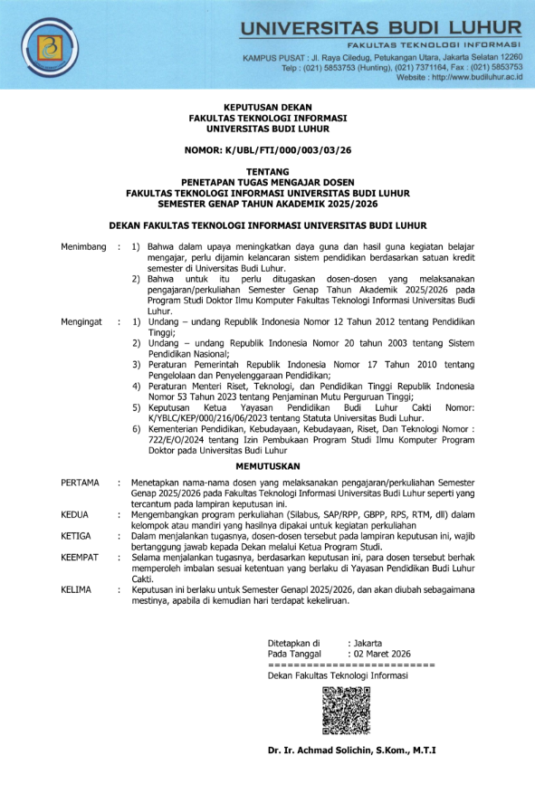
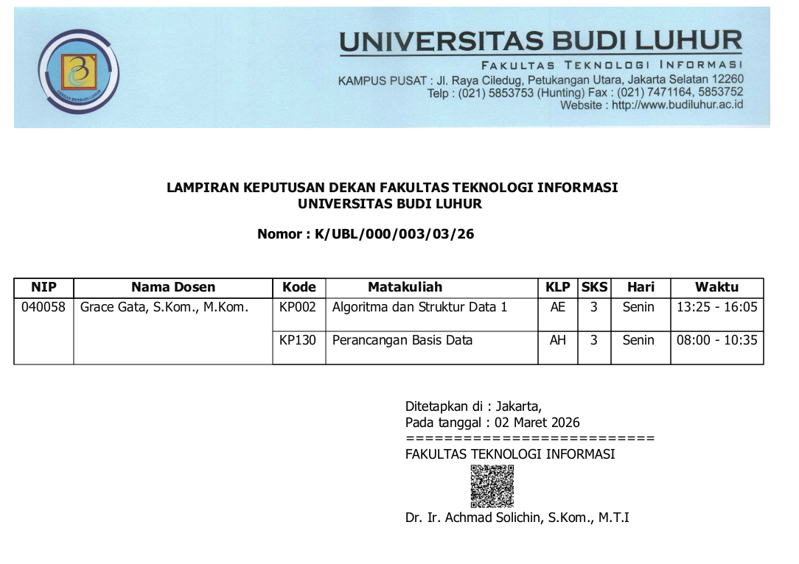

BAP
Berita Acara Mengajar
Fakultas: Fakultas Teknologi Informasi
Matakuliah: Algoritma Dan Struktur Data 1
Kelompok: AE
Dosen: Grace Gata, S.Kom., M.Kom.

No. | Tanggal | Sesi - Jam | Presensi | Materi yangdiberikan
1 | Senin 02-03-2026 | 07 - 13:25 | sudah diisi | Array Dua Dimensi
2 | Senin 09-03-2026 | 07 - 13:25 | sudah diisi | Array Dua Dimensi
3 | Senin 30-03-2026 | 07 - 13:25 | sudah diisi | Array Dua Dimensi
4 | Senin 06-04-2026 | 07 - 13:25 | sudah diisi | Binary Search
5 | Senin 13-04-2026 | 07 - 13:25 | sudah diisi | Sequential Search
6 | Senin 20-04-2026 | 07 - 13:25 | sudah diisi | Bubble Sort
7 | Senin 20-04-2026 | 10 - 16:10 | sudah diisi | Selection Sort
8 | Senin 04-05-2026 | 07 - 13:25 | sudah diisi | UTS
9 | Senin 11-05-2026 | 07 - 13:25 | sudah diisi | insertion sort
10 | Senin 11-05-2026 | 10 - 16:10 | sudah diisi | Merge Sort
11 | Senin 18-05-2026 | 07 - 13:25 | sudah diisi | Pointer
12 | Senin 25-05-2026 | 07 - 13:25 | sudah diisi | Function
13 | Senin 08-06-2026 | 07 - 13:25 | sudah diisi | Fungsi Rekursif
14 | Senin 15-06-2026 | 07 - 13:25 | sudah diisi | Structure
15 | Senin 22-06-2026 | 07 - 13:25 | sudah diisi | File
16 | Senin 29-06-2026 | 07 - 13:25 | sudah diisi | UAS

PRESENSI
Matakuliah: Algoritma dan Struktur Data 1
Kelompok: AE
Semester Genap 2025/2026
Dosen : Grace Gata, S.Kom., M.Kom.
No | NIM | Nama | 1 | 2 | 3 | 4 | 5 | 6 | 7 | 8 | 9 | 10 | 11 | 12 | 13 | 14 | 15 | 16 | %
No | NIM | Nama | 02/03 | 09/03 | 30/03 | 06/04 | 13/04 | 20/04 | 20/04 | 04/05 | 11/05 | 11/05 | 18/05 | 25/05 | 08/06 | 15/06 | 22/06 | 29/06 | %
1 | 2511500056 | Aliando Richard Radjabaycolle | Hadir | Hadir | Hadir | Hadir | Alpha | Alpha | Hadir | Hadir | Alpha | Hadir | Alpha | Hadir | Hadir | Alpha | Hadir | Hadir | 68.75
2 | 2511500155 | Muhammad Rava Jaya Sarliviano | Hadir | Hadir | Hadir | Hadir | Hadir | Hadir | Hadir | Hadir | Hadir | Hadir | Hadir | Hadir | Hadir | Hadir | Hadir | Hadir | 100
3 | 2511500718 | Fahmi Saputra | Hadir | Hadir | Alpha | Hadir | Hadir | Hadir | Hadir | Hadir | Hadir | Hadir | Hadir | Hadir | Alpha | Alpha | Alpha | Alpha | 68.75
4 | 2511500726 | Fauzi Rahmat Ramadhan | Ijin | Hadir | Hadir | Hadir | Alpha | Alpha | Hadir | Alpha | Alpha | Hadir | Alpha | Alpha | Alpha | Alpha | Alpha | Alpha | 37.5
5 | 2511500874 | Yanuar Adhi Nugraha | Alpha | Alpha | Hadir | Hadir | Hadir | Hadir | Hadir | Hadir | Hadir | Hadir | Hadir | Hadir | Hadir | Hadir | Hadir | Hadir | 87.5
6 | 2511500924 | Muhammad Khoirul Umam | Hadir | Hadir | Hadir | Hadir | Alpha | Alpha | Hadir | Alpha | Alpha | Hadir | Alpha | Alpha | Alpha | Alpha | Alpha | Alpha | 37.5
7 | 2511501088 | Alvyndra Razak Koswara | Hadir | Hadir | Hadir | Hadir | Hadir | Hadir | Hadir | Hadir | Hadir | Hadir | Hadir | Hadir | Alpha | Hadir | Hadir | Hadir | 93.75
8 | 2511501310 | Adam Nur Rusly | Alpha | Hadir | Ijin | Hadir | Hadir | Ijin | Hadir | Hadir | Ijin | Hadir | Hadir | Ijin | Hadir | Ijin | Hadir | Hadir | 93.75
9 | 2511501336 | Ryan Babel Christian | Hadir | Hadir | Hadir | Hadir | Hadir | Hadir | Hadir | Hadir | Hadir | Hadir | Alpha | Hadir | Hadir | Alpha | Hadir | Hadir | 87.5
10 | 2511501443 | Farel Febrian Nur | Alpha | Alpha | Hadir | Hadir | Hadir | Hadir | Hadir | Hadir | Hadir | Hadir | Hadir | Hadir | Hadir | Hadir | Hadir | Hadir | 87.5
11 | 2511501476 | Vencent Hortaleza Pepito | Hadir | Hadir | Hadir | Hadir | Hadir | Alpha | Hadir | Hadir | Hadir | Hadir | Hadir | Hadir | Hadir | Alpha | Hadir | Hadir | 87.5
12 | 2511501732 | Muhammad Riffat Morano Pardomuan Siregar | Hadir | Hadir | Hadir | Hadir | Hadir | Hadir | Hadir | Hadir | Hadir | Hadir | Hadir | Hadir | Hadir | Hadir | Hadir | Hadir | 100
13 | 2511501898 | Clarisa Erline Tefa | Ijin | Hadir | Hadir | Hadir | Hadir | Hadir | Hadir | Hadir | Hadir | Hadir | Hadir | Hadir | Hadir | Hadir | Hadir | Hadir | 100
14 | 2511501906 | Muhammad Adlin Agastyan | Hadir | Hadir | Hadir | Hadir | Hadir | Hadir | Hadir | Hadir | Hadir | Hadir | Hadir | Hadir | Hadir | Hadir | Hadir | Hadir | 100
15 | 2511502037 | Azka Sazkia Usmani | Hadir | Hadir | Hadir | Hadir | Hadir | Hadir | Hadir | Hadir | Hadir | Hadir | Hadir | Hadir | Hadir | Hadir | Hadir | Hadir | 100
16 | 2511502102 | Destra Fadhilah | Hadir | Hadir | Hadir | Hadir | Hadir | Hadir | Hadir | Hadir | Hadir | Hadir | Hadir | Hadir | Hadir | Hadir | Hadir | Hadir | 100
17 | 2511502300 | Lakeisya Aulia Fitriah | Hadir | Hadir | Alpha | Hadir | Ijin | Hadir | Hadir | Hadir | Hadir | Hadir | Hadir | Hadir | Hadir | Hadir | Hadir | Hadir | 93.75
18 | 2511502391 | Shaepto Satrio | Alpha | Alpha | Alpha | Alpha | Alpha | Alpha | Hadir | Alpha | Alpha | Hadir | Alpha | Alpha | Alpha | Alpha | Alpha | Alpha | 12.5
19 | 2512500188 | Muhammad Arfan | Hadir | Hadir | Alpha | Hadir | Hadir | Hadir | Hadir | Hadir | Hadir | Hadir | Hadir | Hadir | Hadir | Hadir | Hadir | Hadir | 93.75
20 | 2512500428 | Muhammad Rafka Putra | Hadir | Hadir | Hadir | Hadir | Hadir | Hadir | Hadir | Hadir | Hadir | Hadir | Hadir | Hadir | Hadir | Hadir | Hadir | Hadir | 100
21 | 2512500584 | Ahmad Ardi Alamsyah | Hadir | Hadir | Hadir | Alpha | Hadir | Hadir | Hadir | Hadir | Ijin | Hadir | Ijin | Alpha | Hadir | Hadir | Ijin | Hadir | 87.5
22 | 2512500675 | Muhammad Fachril Ramdan | Hadir | Hadir | Hadir | Hadir | Hadir | Alpha | Hadir | Hadir | Hadir | Hadir | Hadir | Hadir | Hadir | Hadir | Hadir | Hadir | 93.75
23 | 2512500725 | Muhammad Nabil Ramadhani | Hadir | Hadir | Hadir | Hadir | Hadir | Hadir | Hadir | Hadir | Hadir | Hadir | Hadir | Hadir | Hadir | Hadir | Hadir | Hadir | 100
24 | 2512500824 | Aldi Febrian Arrahman | Hadir | Hadir | Hadir | Hadir | Hadir | Hadir | Hadir | Hadir | Hadir | Hadir | Hadir | Hadir | Hadir | Hadir | Hadir | Hadir | 100
25 | 2512500931 | Andhika Mulya Pratama | Hadir | Hadir | Hadir | Hadir | Hadir | Hadir | Hadir | Hadir | Hadir | Hadir | Hadir | Alpha | Hadir | Hadir | Hadir | Hadir | 93.75
26 | 2512501202 | Javana Maulana Putra | Hadir | Hadir | Hadir | Hadir | Hadir | Hadir | Hadir | Hadir | Hadir | Hadir | Hadir | Hadir | Hadir | Alpha | Hadir | Hadir | 93.75
27 | 2512501236 | Jessica Aulia Ahmad | Hadir | Hadir | Hadir | Hadir | Hadir | Hadir | Hadir | Hadir | Hadir | Hadir | Hadir | Hadir | Hadir | Hadir | Hadir | Hadir | 100
28 | 2512501277 | Ahmadinejad Al Fateh | Hadir | Hadir | Hadir | Hadir | Hadir | Alpha | Hadir | Hadir | Hadir | Hadir | Hadir | Hadir | Hadir | Hadir | Hadir | Hadir | 93.75
29 | 2512501293 | Ahmad Yusuf Zawhari | Hadir | Hadir | Hadir | Hadir | Hadir | Hadir | Hadir | Hadir | Alpha | Hadir | Hadir | Hadir | Hadir | Hadir | Hadir | Hadir | 93.75
30 | 2512501301 | Naztwa Hibatullah Mahmud | Ijin | Ijin | Alpha | Ijin | Hadir | Hadir | Hadir | Hadir | Hadir | Hadir | Hadir | Hadir | Hadir | Hadir | Hadir | Hadir | 93.75
31 | 2512501459 | Naila Safitri | Hadir | Hadir | Hadir | Hadir | Hadir | Hadir | Hadir | Hadir | Hadir | Hadir | Hadir | Ijin | Hadir | Hadir | Hadir | Hadir | 100
32 | 2512501640 | Vania Reva Nita | Ijin | Hadir | Hadir | Hadir | Hadir | Hadir | Hadir | Hadir | Hadir | Hadir | Hadir | Hadir | Hadir | Hadir | Hadir | Hadir | 100
33 | 2513500112 | Rakha Ramadhan Putra | Hadir | Hadir | Hadir | Hadir | Ijin | Hadir | Hadir | Hadir | Ijin | Hadir | Hadir | Hadir | Hadir | Hadir | Hadir | Hadir | 100
34 | 2513500161 | Rully Erlando | Alpha | Alpha | Alpha | Alpha | Alpha | Alpha | Hadir | Alpha | Alpha | Hadir | Alpha | Alpha | Alpha | Alpha | Alpha | Alpha | 12.5
35 | 2513500229 | Susanto Adi Nugroho | Alpha | Alpha | Alpha | Hadir | Hadir | Hadir | Hadir | Hadir | Hadir | Hadir | Hadir | Hadir | Hadir | Hadir | Hadir | Hadir | 81.25

NILAI
Fakultas: Fakultas Teknologi Informasi
Matakuliah: Algoritma Dan Struktur Data 1
Kelompok: AE
Dosen: Grace Gata, S.Kom., M.Kom.
No. | NIM | Nama | Presensi | Tugas | Midtest | Final | Prediksi Grade
1 | 2511500056 | Aliando Richard Radjabaycolle | 69 % | 50 | 60 | 28 | 44 => E
2 | 2511500155 | Muhammad Rava Jaya Sarliviano | 100 % | 100 | 60 | 78 | 79 => B+
3 | 2511500718 | Fahmi Saputra | 69 % | 999 | 60 | 999 | 18 => -
4 | 2511500726 | Fauzi Rahmat Ramadhan | 38 % | 999 | 999 | 999 | 0 => -
5 | 2511500874 | Yanuar Adhi Nugraha | 88 % | 57 | 50 | 69 | 60 => C
6 | 2511500924 | Muhammad Khoirul Umam | 38 % | 999 | 999 | 999 | 0 => -
7 | 2511501088 | Alvyndra Razak Koswara | 94 % | 30 | 75 | 89 | 67 => B-
8 | 2511501310 | Adam Nur Rusly | 94 % | 57 | 60 | 80 | 67 => B-
9 | 2511501336 | Ryan Babel Christian | 88 % | 57 | 50 | 82 | 65 => B-
10 | 2511501443 | Farel Febrian Nur | 88 % | 50 | 60 | 68 | 60 => C
11 | 2511501476 | Vencent Hortaleza Pepito | 88 % | 100 | 70 | 93 | 88 => A
12 | 2511501732 | Muhammad Riffat Morano Pardomuan Siregar | 100 % | 100 | 60 | 93 | 85 => A
13 | 2511501898 | Clarisa Erline Tefa | 100 % | 100 | 85 | 88 | 91 => A
14 | 2511501906 | Muhammad Adlin Agastyan | 100 % | 100 | 60 | 60 | 72 => B
15 | 2511502037 | Azka Sazkia Usmani | 100 % | 100 | 75 | 75 | 83 => A-
16 | 2511502102 | Destra Fadhilah | 100 % | 100 | 60 | 90 | 84 => A-
17 | 2511502300 | Lakeisya Aulia Fitriah | 94 % | 100 | 60 | 65 | 74 => B
18 | 2511502391 | Shaepto Satrio | 13 % | 999 | 999 | 999 | 0 => -
19 | 2512500188 | Muhammad Arfan | 94 % | 100 | 60 | 73 | 77 => B+
20 | 2512500428 | Muhammad Rafka Putra | 100 % | 100 | 60 | 70 | 76 => B+
21 | 2512500584 | Ahmad Ardi Alamsyah | 88 % | 100 | 64 | 68 | 76 => B+
22 | 2512500675 | Muhammad Fachril Ramdan | 94 % | 95 | 60 | 73 | 76 => B+
23 | 2512500725 | Muhammad Nabil Ramadhani | 100 % | 100 | 60 | 73 | 77 => B+
24 | 2512500824 | Aldi Febrian Arrahman | 100 % | 100 | 60 | 70 | 76 => B+
25 | 2512500931 | Andhika Mulya Pratama | 94 % | 100 | 64 | 83 | 82 => A-
26 | 2512501202 | Javana Maulana Putra | 94 % | 30 | 95 | 100 | 78 => B+
27 | 2512501236 | Jessica Aulia Ahmad | 100 % | 100 | 80 | 93 | 91 => A
28 | 2512501277 | Ahmadinejad Al Fateh | 94 % | 80 | 60 | 50 | 62 => C
29 | 2512501293 | Ahmad Yusuf Zawhari | 94 % | 100 | 60 | 93 | 85 => A
30 | 2512501301 | Naztwa Hibatullah Mahmud | 94 % | 100 | 60 | 93 | 85 => A
31 | 2512501459 | Naila Safitri | 100 % | 50 | 75 | 70 | 66 => B-
32 | 2512501640 | Vania Reva Nita | 100 % | 100 | 70 | 85 | 85 => A
33 | 2513500112 | Rakha Ramadhan Putra | 100 % | 100 | 65 | 85 | 84 => A-
34 | 2513500161 | Rully Erlando | 13 % | 999 | 999 | 999 | 0 => -
35 | 2513500229 | Susanto Adi Nugroho | 81 % | 80 | 60 | 78 | 73 => B

