BIDANG B PENGAJARAN

SK

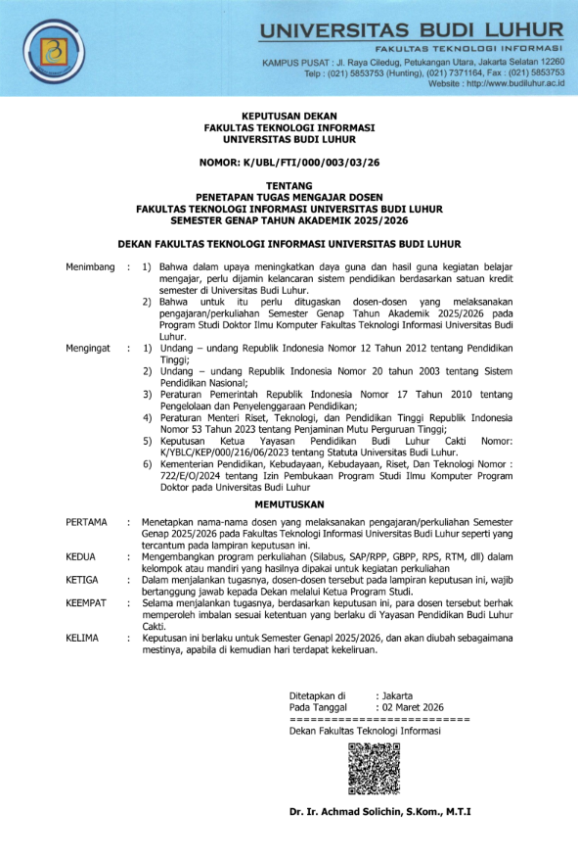
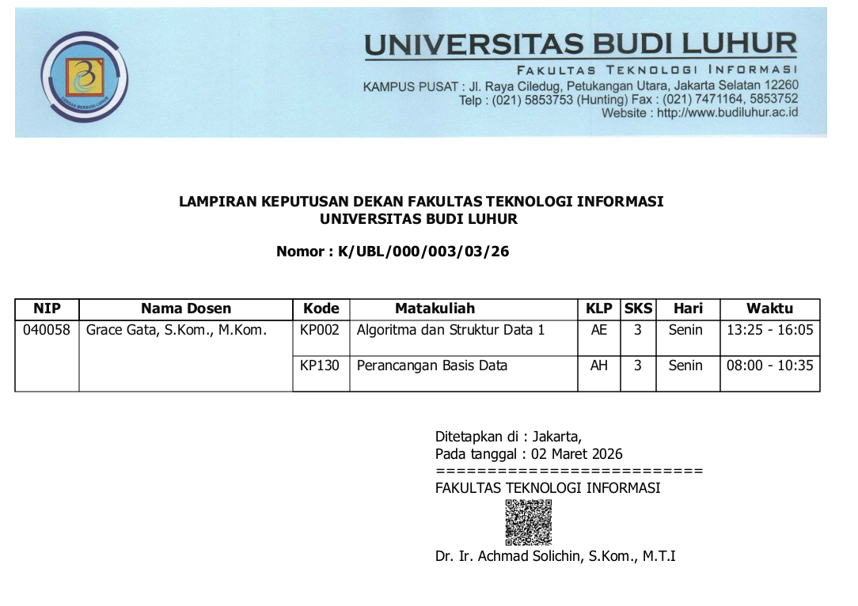

BAP
Berita Acara Mengajar
Fakultas: Fakultas Teknologi Informasi
Matakuliah: Perancangan Basis Data
Kelompok: AH
Dosen: Grace Gata, S.Kom., M.Kom.

No. | Tanggal | Sesi - Jam | Presensi | Materi yangdiberikan
1 | Senin 02-03-2026 | 01 - 08:00 | sudah diisi | Proses Perancangan basis data
2 | Senin 09-03-2026 | 01 - 08:00 | sudah diisi | Teknik Pengumpulan Data
3 | Senin 30-03-2026 | 01 - 08:00 | sudah diisi | Entity Relationship Diagram
4 | Senin 06-04-2026 | 01 - 08:00 | sudah diisi | Model Konseptual dengan ER-Model Lanjutan
5 | Senin 13-04-2026 | 01 - 08:00 | sudah diisi | Tahapan Rancangan ERD
6 | Senin 20-04-2026 | 01 - 08:00 | sudah diisi | Logical Record Structure (LRS)
7 | Senin 20-04-2026 | 04 - 10:40 | sudah diisi | review materi
8 | Senin 04-05-2026 | 01 - 08:00 | sudah diisi | UTS
9 | Senin 11-05-2026 | 01 - 08:00 | sudah diisi | Physical Database Design
10 | Senin 11-05-2026 | 04 - 10:40 | sudah diisi | Penormalan Relasi
11 | Senin 18-05-2026 | 01 - 08:00 | sudah diisi | Penormalan Relasi Lanjutan
12 | Jumat 29-05-2026 | 07 - 13:25 | sudah diisi | normalisasi lanjutan
13 | Senin 08-06-2026 | 01 - 08:00 | sudah diisi | Penyelesaian kasus normalisasi dan denormalisasi
14 | Senin 15-06-2026 | 01 - 08:00 | sudah diisi | Data Warehouse
15 | Senin 22-06-2026 | 01 - 08:00 | sudah diisi | Latihan soal
16 | Senin 29-06-2026 | 01 - 08:00 | sudah diisi | UAS

PRESENSI
Matakuliah: Perancangan Basis Data
Kelompok: AH
Semester Genap 2025/2026
Dosen : Grace Gata, S.Kom., M.Kom.
No | NIM | Nama | 1 | 2 | 3 | 4 | 5 | 6 | 7 | 8 | 9 | 10 | 11 | 12 | 13 | 14 | 15 | 16 | %
No | NIM | Nama | 02/03 | 09/03 | 30/03 | 06/04 | 13/04 | 20/04 | 20/04 | 04/05 | 11/05 | 11/05 | 18/05 | 29/05 | 08/06 | 15/06 | 22/06 | 29/06 | %
1 | 2211500778 | Mochammad Riyzza Sudradjat | Ijin | Hadir | Ijin | Ijin | Ijin | Ijin | Hadir | Ijin | Ijin | Hadir | Ijin | Hadir | Ijin | Alpha | Alpha | Alpha | 81.25
2 | 2511500015 | Destanto Juan Timoti | Hadir | Hadir | Hadir | Hadir | Hadir | Ijin | Hadir | Hadir | Hadir | Hadir | Hadir | Hadir | Hadir | Hadir | Hadir | Hadir | 100
3 | 2511500429 | Agustinus Koa | Hadir | Hadir | Ijin | Hadir | Hadir | Ijin | Hadir | Hadir | Hadir | Hadir | Hadir | Hadir | Alpha | Hadir | Alpha | Hadir | 87.5
4 | 2511500502 | Hikhmah Nauli Lubis | Hadir | Hadir | Ijin | Ijin | Hadir | Ijin | Hadir | Hadir | Hadir | Hadir | Hadir | Hadir | Hadir | Hadir | Alpha | Hadir | 93.75
5 | 2511500767 | Aslama Qiel | Alpha | Ijin | Ijin | Ijin | Hadir | Alpha | Hadir | Hadir | Hadir | Hadir | Hadir | Hadir | Hadir | Hadir | Hadir | Hadir | 87.5
6 | 2511500775 | Mohamad Akbar Ramadhan | Hadir | Ijin | Ijin | Ijin | Ijin | Ijin | Hadir | Ijin | Ijin | Hadir | Hadir | Hadir | Alpha | Alpha | Alpha | Hadir | 81.25
7 | 2511500833 | Daud Aqil Bahij Afif | Hadir | Hadir | Hadir | Hadir | Hadir | Hadir | Hadir | Hadir | Hadir | Hadir | Hadir | Hadir | Hadir | Hadir | Hadir | Hadir | 100
8 | 2511500999 | Hodhi Murfid | Hadir | Hadir | Ijin | Hadir | Hadir | Hadir | Hadir | Hadir | Hadir | Hadir | Hadir | Hadir | Hadir | Hadir | Alpha | Hadir | 93.75
9 | 2511501005 | RAIHAN AL GHIFARY | Hadir | Hadir | Hadir | Ijin | Hadir | Hadir | Hadir | Hadir | Hadir | Hadir | Hadir | Hadir | Hadir | Hadir | Hadir | Hadir | 100
10 | 2511501153 | Bagas Nur Ramadhan | Hadir | Hadir | Hadir | Hadir | Hadir | Hadir | Hadir | Hadir | Hadir | Hadir | Hadir | Hadir | Hadir | Hadir | Hadir | Hadir | 100
11 | 2511501195 | Ryo Moelya Sahputra | Hadir | Hadir | Hadir | Hadir | Hadir | Hadir | Hadir | Hadir | Hadir | Hadir | Hadir | Hadir | Hadir | Hadir | Hadir | Hadir | 100
12 | 2511501229 | Gloris Ganesa Pribadi | Hadir | Ijin | Ijin | Ijin | Hadir | Hadir | Hadir | Hadir | Alpha | Hadir | Hadir | Hadir | Hadir | Alpha | Alpha | Hadir | 81.25
13 | 2511501401 | Suhada Fadhil Alfarisi | Hadir | Hadir | Hadir | Hadir | Ijin | Alpha | Hadir | Hadir | Alpha | Hadir | Hadir | Hadir | Alpha | Ijin | Hadir | Hadir | 81.25
14 | 2511501443 | Farel Febrian Nur | Hadir | Hadir | Hadir | Hadir | Hadir | Alpha | Hadir | Hadir | Hadir | Hadir | Hadir | Hadir | Hadir | Hadir | Hadir | Hadir | 93.75
15 | 2511501690 | Kaysan Ahmad Lutfi | Hadir | Hadir | Hadir | Hadir | Hadir | Hadir | Hadir | Hadir | Hadir | Hadir | Hadir | Hadir | Hadir | Hadir | Hadir | Hadir | 100
16 | 2511501872 | Mujtahid Zaki Pratisno Jati | Hadir | Hadir | Alpha | Hadir | Ijin | Hadir | Hadir | Hadir | Hadir | Hadir | Ijin | Hadir | Ijin | Hadir | Hadir | Hadir | 93.75
17 | 2511501955 | Zacky Attallah Siswanto | Alpha | Alpha | Ijin | Hadir | Hadir | Ijin | Hadir | Hadir | Alpha | Hadir | Ijin | Hadir | Hadir | Hadir | Ijin | Hadir | 81.25
18 | 2511502367 | Muhammad Mahdi Zikri | Alpha | Hadir | Alpha | Ijin | Alpha | Ijin | Hadir | Alpha | Alpha | Hadir | Alpha | Hadir | Alpha | Alpha | Alpha | Alpha | 37.5
19 | 2511502417 | Muhammad Restu | Alpha | Alpha | Alpha | Alpha | Alpha | Alpha | Hadir | Alpha | Alpha | Hadir | Alpha | Hadir | Alpha | Alpha | Alpha | Alpha | 18.75
20 | 2512500063 | Ramadhan Nur Faizi | Hadir | Hadir | Hadir | Hadir | Hadir | Alpha | Hadir | Hadir | Hadir | Hadir | Hadir | Hadir | Alpha | Ijin | Alpha | Alpha | 75
21 | 2512500204 | Fiqih Ihyarudin | Hadir | Hadir | Hadir | Hadir | Hadir | Hadir | Hadir | Hadir | Hadir | Hadir | Hadir | Hadir | Hadir | Hadir | Hadir | Hadir | 100
22 | 2512500220 | Miko Arrafi | Alpha | Hadir | Alpha | Alpha | Hadir | Hadir | Hadir | Hadir | Alpha | Hadir | Hadir | Hadir | Alpha | Alpha | Alpha | Hadir | 56.25
23 | 2512500253 | Muhammad Raafi | Hadir | Hadir | Hadir | Hadir | Hadir | Hadir | Hadir | Hadir | Hadir | Hadir | Hadir | Hadir | Hadir | Hadir | Hadir | Hadir | 100
24 | 2512500840 | Arya Raafi Wijaya | Hadir | Hadir | Hadir | Hadir | Ijin | Ijin | Hadir | Hadir | Hadir | Hadir | Hadir | Hadir | Hadir | Hadir | Hadir | Hadir | 100
25 | 2512501186 | Muhammad Azka Adam Zhafran | Alpha | Hadir | Alpha | Alpha | Alpha | Alpha | Hadir | Alpha | Alpha | Hadir | Alpha | Hadir | Ijin | Alpha | Alpha | Alpha | 31.25
26 | 2512501343 | Muhammad Irshad Hakim | Hadir | Hadir | Hadir | Hadir | Hadir | Ijin | Hadir | Hadir | Hadir | Hadir | Hadir | Hadir | Hadir | Hadir | Hadir | Hadir | 100
27 | 2512501780 | Muhammad Dafa | Hadir | Hadir | Hadir | Ijin | Hadir | Ijin | Hadir | Hadir | Hadir | Hadir | Hadir | Hadir | Hadir | Hadir | Hadir | Hadir | 100
28 | 2512501814 | Meilani Putri | Ijin | Ijin | Ijin | Ijin | Ijin | Hadir | Hadir | Hadir | Hadir | Hadir | Hadir | Hadir | Hadir | Hadir | Alpha | Hadir | 93.75

NILAI
Fakultas: Fakultas Teknologi Informasi
Matakuliah: Perancangan Basis Data
Kelompok: AH
Dosen: Grace Gata, S.Kom., M.Kom.

No. | NIM | Nama | Presensi | Tugas | Midtest | Final | Prediksi Grade
1 | 2211500778 | Mochammad Riyzza Sudradjat | 81 % | 999 | 999 | 999 | 0 => -
2 | 2511500015 | Destanto Juan Timoti | 100 % | 80 | 65 | 55 | 66 => B-
3 | 2511500429 | Agustinus Koa | 88 % | 90 | 65 | 65 | 73 => B
4 | 2511500502 | Hikhmah Nauli Lubis | 94 % | 60 | 65 | 55 | 60 => C
5 | 2511500767 | Aslama Qiel | 88 % | 70 | 65 | 60 | 65 => B-
6 | 2511500775 | Mohamad Akbar Ramadhan | 81 % | 999 | 999 | 10 | 4 => E
7 | 2511500833 | Daud Aqil Bahij Afif | 100 % | 90 | 65 | 84 | 80 => A-
8 | 2511500999 | Hodhi Murfid | 94 % | 90 | 65 | 68 | 74 => B
9 | 2511501005 | RAIHAN AL GHIFARY | 100 % | 60 | 65 | 70 | 66 => B-
10 | 2511501153 | Bagas Nur Ramadhan | 100 % | 90 | 65 | 74 | 76 => B+
11 | 2511501195 | Ryo Moelya Sahputra | 100 % | 80 | 65 | 74 | 73 => B
12 | 2511501229 | Gloris Ganesa Pribadi | 81 % | 70 | 64 | 63 | 65 => B-
13 | 2511501401 | Suhada Fadhil Alfarisi | 81 % | 60 | 64 | 70 | 65 => B-
14 | 2511501443 | Farel Febrian Nur | 94 % | 90 | 65 | 70 | 75 => B+
15 | 2511501690 | Kaysan Ahmad Lutfi | 100 % | 80 | 65 | 60 | 68 => B-
16 | 2511501872 | Mujtahid Zaki Pratisno Jati | 94 % | 80 | 65 | 78 | 75 => B+
17 | 2511501955 | Zacky Attallah Siswanto | 81 % | 70 | 65 | 60 | 65 => B-
18 | 2511502367 | Muhammad Mahdi Zikri | 38 % | 999 | 999 | 999 | 0 => -
19 | 2511502417 | Muhammad Restu | 19 % | 999 | 999 | 999 | 0 => -
20 | 2512500063 | Ramadhan Nur Faizi | 75 % | 999 | 65 | 999 | 20 => -
21 | 2512500204 | Fiqih Ihyarudin | 100 % | 90 | 65 | 91 | 83 => A-
22 | 2512500220 | Miko Arrafi | 56 % | 999 | 64 | 999 | 19 => -
23 | 2512500253 | Muhammad Raafi | 100 % | 100 | 65 | 76 | 80 => A-
24 | 2512500840 | Arya Raafi Wijaya | 100 % | 80 | 65 | 76 | 74 => B
25 | 2512501186 | Muhammad Azka Adam Zhafran | 31 % | 999 | 999 | 999 | 0 => -
26 | 2512501343 | Muhammad Irshad Hakim | 100 % | 90 | 65 | 65 | 73 => B
27 | 2512501780 | Muhammad Dafa | 100 % | 90 | 65 | 72 | 75 => B+
28 | 2512501814 | Meilani Putri | 94 % | 90 | 65 | 50 | 67 => B-

