BIDANG B PENGAJARAN
Fakultas: Fakultas Teknologi Informasi
Matakuliah: Perancangan Basis Data
Kelompok: AD
Dosen: Grace Gata, S.Kom., M.Kom.

SK

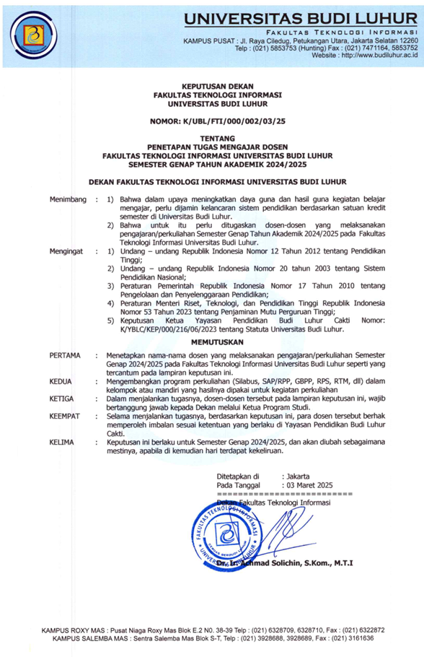
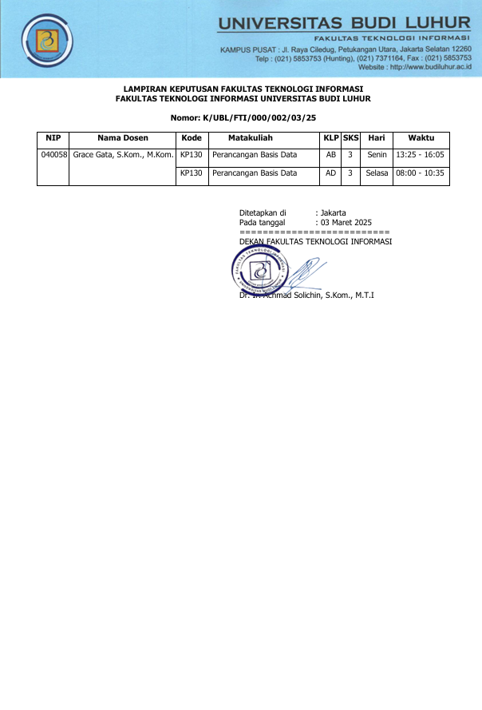

BAP
Berita Acara Mengajar
Fakultas: Fakultas Teknologi Informasi
Matakuliah: Perancangan Basis Data
Kelompok: AD
Dosen: Grace Gata, S.Kom., M.Kom.

No. | Tanggal | Sesi - Jam | Materi yangdiberikan
1 | Selasa 04-03-2025 | 01 - 08:00 | Proses Perancangan Basis Data
2 | Selasa 11-03-2025 | 01 - 08:00 | Teknik Pengumpulan Data
3 | Selasa 18-03-2025 | 01 - 08:00 | Model Konseptual Dengan ER-Model
4 | Kamis 10-04-2025 | 07 - 13:25 | Model Konseptual dengan ER-Model Lanjutan
5 | Selasa 15-04-2025 | 01 - 08:00 | Tahapan perancangan ERD
6 | Selasa 22-04-2025 | 01 - 08:00 | Logical Record Structure (LRS)
7 | Senin 28-04-2025 | 04 - 10:40 | Review Materi
8 | Selasa 06-05-2025 | 01 - 08:00 | UTS
9 | Kamis 15-05-2025 | 07 - 13:25 | Physical Database Design
10 | Selasa 20-05-2025 | 01 - 08:00 | Penormalan Relasi
11 | Selasa 27-05-2025 | 01 - 08:00 | Penormalan Relasi Lanjutan
12 | Selasa 03-06-2025 | 01 - 08:00 | Normalisasi Lanjutan
13 | Selasa 10-06-2025 | 01 - 08:00 | penyelesaikan kasus normalisasi dan denormalisasi
14 | Selasa 17-06-2025 | 01 - 08:00 | data warehouse
15 | Selasa 24-06-2025 | 01 - 08:00 | Latihan Soal
16 | Selasa 08-07-2025 | 01 - 08:00 | UAS

PRESENSI
Matakuliah: Perancangan Basis Data
Kelompok: AD
Semester Genap 2024/2025
Dosen : Grace Gata, S.Kom., M.Kom.
No | NIM | Nama | 1 | 2 | 3 | 4 | 5 | 6 | 7 | 8 | 9 | 10 | 11 | 12 | 13 | 14 | 15 | 16 | %
No | NIM | Nama | 04/03 | 11/03 | 18/03 | 10/04 | 15/04 | 22/04 | 28/04 | 06/05 | 15/05 | 20/05 | 27/05 | 03/06 | 10/06 | 17/06 | 24/06 | 08/07 | %
1 | 2011501760 | Danang Suryo Lukito | Alpha | Hadir | Hadir | Hadir | Alpha | Hadir | Hadir | Hadir | Hadir | Alpha | Alpha | Alpha | Hadir | Hadir | Hadir | Hadir | 64.29
2 | 2111500951 | SHAFINA DWIANDRA PUTRI | Alpha | Alpha | Alpha | Hadir | Alpha | Hadir | Hadir | Alpha | Hadir | Alpha | Alpha | Alpha | Alpha | Alpha | Alpha | Alpha | 28.57
3 | 2211501909 | Muhammad Rafly Pradipta | Alpha | Hadir | Hadir | Hadir | Hadir | Hadir | Hadir | Hadir | Hadir | Alpha | Alpha | Alpha | Hadir | Alpha | Alpha | Alpha | 64.29
4 | 2212500074 | Muhammad Ridwan | Hadir | Hadir | Hadir | Hadir | Alpha | Hadir | Hadir | Hadir | Hadir | Hadir | Alpha | Alpha | Hadir | Hadir | Hadir | Hadir | 71.43
5 | 2311500397 | Naldo Febriano | Hadir | Hadir | Hadir | Hadir | Hadir | Hadir | Hadir | Hadir | Hadir | Hadir | Hadir | Alpha | Alpha | Hadir | Hadir | Hadir | 78.57
6 | 2311500488 | Dwi Satrio Yudhanto | Hadir | Hadir | Hadir | Hadir | Alpha | Hadir | Hadir | Hadir | Hadir | Hadir | Hadir | Hadir | Hadir | Hadir | Hadir | Hadir | 85.71
7 | 2311500520 | Pascal Jericho Basaur | Alpha | Alpha | Hadir | Hadir | Alpha | Hadir | Hadir | Hadir | Hadir | Alpha | Alpha | Alpha | Alpha | Alpha | Alpha | Alpha | 42.86
8 | 2311500538 | Muhammad Ariiq Firdaus | Alpha | Alpha | Alpha | Hadir | Alpha | Hadir | Hadir | Hadir | Hadir | Hadir | Alpha | Alpha | Alpha | Hadir | Hadir | Hadir | 42.86
9 | 2311500660 | Farhan Saputra | Hadir | Hadir | Hadir | Hadir | Hadir | Hadir | Hadir | Hadir | Hadir | Hadir | Alpha | Alpha | Alpha | Hadir | Hadir | Hadir | 71.43
10 | 2311500835 | Raudatuz Zahra | Alpha | Hadir | Hadir | Hadir | Alpha | Hadir | Hadir | Alpha | Hadir | Alpha | Alpha | Alpha | Alpha | Alpha | Alpha | Alpha | 42.86
11 | 2311500975 | Muhammad Adry Aspari | Alpha | Hadir | Hadir | Hadir | Hadir | Hadir | Hadir | Hadir | Hadir | Hadir | Hadir | Hadir | Alpha | Hadir | Hadir | Hadir | 85.71
12 | 2311501122 | Al Farrel Fabryan | Hadir | Hadir | Hadir | Hadir | Alpha | Hadir | Hadir | Hadir | Hadir | Hadir | Alpha | Alpha | Alpha | Hadir | Hadir | Hadir | 71.43
13 | 2311501361 | Bintang Naufal Syarief | Alpha | Hadir | Hadir | Hadir | Hadir | Hadir | Hadir | Hadir | Hadir | Hadir | Hadir | Hadir | Hadir | Alpha | Alpha | Alpha | 85.71
14 | 2311501593 | Afrian Hifni Nizham Prawoto | Hadir | Hadir | Hadir | Hadir | Hadir | Hadir | Hadir | Hadir | Hadir | Hadir | Alpha | Hadir | Alpha | Hadir | Hadir | Hadir | 78.57
15 | 2411500081 | Muhammad Abdel Fattah Abdillah | Alpha | Alpha | Alpha | Hadir | Hadir | Hadir | Hadir | Hadir | Hadir | Hadir | Hadir | Hadir | Hadir | Hadir | Hadir | Hadir | 78.57
16 | 2411500966 | Chaerul Akmal | Hadir | Hadir | Hadir | Hadir | Hadir | Hadir | Hadir | Hadir | Hadir | Hadir | Alpha | Hadir | Alpha | Hadir | Hadir | Hadir | 78.57
17 | 2411501022 | Rafael Ruben | Hadir | Hadir | Hadir | Hadir | Hadir | Hadir | Hadir | Hadir | Hadir | Hadir | Hadir | Hadir | Hadir | Hadir | Hadir | Hadir | 100
18 | 2411501147 | Fahrul Fahrezi | Hadir | Hadir | Hadir | Hadir | Hadir | Hadir | Hadir | Hadir | Hadir | Hadir | Hadir | Hadir | Hadir | Hadir | Hadir | Hadir | 100
19 | 2411501246 | Abu Dzar Al Ghifari | Hadir | Hadir | Hadir | Hadir | Hadir | Hadir | Hadir | Hadir | Hadir | Alpha | Hadir | Hadir | Hadir | Hadir | Hadir | Hadir | 92.86
20 | 2411501311 | Fadli Dzil Ikram | Hadir | Hadir | Hadir | Hadir | Hadir | Hadir | Hadir | Hadir | Hadir | Hadir | Hadir | Hadir | Hadir | Hadir | Hadir | Hadir | 100
21 | 2411501568 | Muhammad Saddam Ryuga Octoramdhani | Hadir | Hadir | Hadir | Hadir | Hadir | Hadir | Hadir | Hadir | Hadir | Hadir | Alpha | Hadir | Hadir | Hadir | Hadir | Hadir | 85.71
22 | 2411501592 | Muhamad Faiq Nurfaizi | Alpha | Hadir | Hadir | Hadir | Alpha | Hadir | Hadir | Hadir | Hadir | Hadir | Hadir | Hadir | Hadir | Hadir | Hadir | Hadir | 85.71
23 | 2411501642 | Raden Ezra Rahmaditya | Hadir | Hadir | Hadir | Hadir | Hadir | Hadir | Hadir | Hadir | Hadir | Alpha | Hadir | Hadir | Hadir | Hadir | Hadir | Hadir | 85.71
24 | 2411501733 | Muhammad Rakan Al Ghazali | Alpha | Hadir | Hadir | Hadir | Alpha | Hadir | Hadir | Hadir | Hadir | Hadir | Alpha | Hadir | Hadir | Hadir | Hadir | Hadir | 78.57
25 | 2411501766 | Hylmi Fikri Darmawan | Alpha | Alpha | Hadir | Hadir | Alpha | Hadir | Hadir | Alpha | Hadir | Alpha | Alpha | Alpha | Alpha | Alpha | Alpha | Alpha | 35.71
26 | 2411501808 | Raihan Fikri Ramadhan | Alpha | Hadir | Hadir | Hadir | Hadir | Hadir | Hadir | Hadir | Hadir | Alpha | Hadir | Hadir | Hadir | Hadir | Hadir | Hadir | 85.71
27 | 2411501865 | Zahfandhika Fauzan Maldini | Hadir | Hadir | Hadir | Hadir | Hadir | Hadir | Hadir | Hadir | Hadir | Hadir | Hadir | Hadir | Hadir | Hadir | Hadir | Hadir | 92.86
28 | 2411501899 | Ghina Alyana Arika | Hadir | Hadir | Hadir | Hadir | Hadir | Hadir | Hadir | Hadir | Hadir | Hadir | Alpha | Hadir | Hadir | Hadir | Hadir | Hadir | 92.86
29 | 2411501907 | Revalina | Hadir | Hadir | Hadir | Hadir | Alpha | Hadir | Hadir | Hadir | Hadir | Hadir | Alpha | Hadir | Hadir | Hadir | Hadir | Hadir | 85.71
30 | 2411501931 | Muhammad Davilla Alfarizi Hadi | Hadir | Hadir | Hadir | Hadir | Hadir | Hadir | Hadir | Hadir | Hadir | Alpha | Hadir | Hadir | Hadir | Hadir | Hadir | Hadir | 85.71
31 | 2411501964 | Muhammad Bintang Ramadhan | Hadir | Alpha | Hadir | Hadir | Hadir | Hadir | Hadir | Hadir | Hadir | Hadir | Hadir | Hadir | Hadir | Hadir | Hadir | Hadir | 92.86
32 | 2411501980 | Alfin Setiawan | Alpha | Alpha | Hadir | Hadir | Alpha | Hadir | Hadir | Hadir | Hadir | Hadir | Hadir | Hadir | Hadir | Hadir | Hadir | Hadir | 78.57
33 | 2411502004 | Kin Mahmud Abbasil | Hadir | Hadir | Hadir | Hadir | Hadir | Hadir | Hadir | Hadir | Hadir | Hadir | Hadir | Alpha | Alpha | Hadir | Hadir | Hadir | 85.71
34 | 2412500171 | Zelmustav Ramadhan | Hadir | Hadir | Hadir | Hadir | Alpha | Hadir | Hadir | Hadir | Hadir | Hadir | Alpha | Hadir | Hadir | Hadir | Hadir | Hadir | 85.71
35 | 2412500874 | Rahmat Yudianto | Alpha | Hadir | Hadir | Hadir | Alpha | Hadir | Hadir | Hadir | Hadir | Alpha | Alpha | Hadir | Alpha | Alpha | Alpha | Alpha | 57.14
36 | 2412501302 | Ali Imron Ismauna | Hadir | Hadir | Hadir | Hadir | Hadir | Hadir | Hadir | Hadir | Hadir | Hadir | Alpha | Hadir | Hadir | Hadir | Hadir | Hadir | 92.86
37 | 2412501393 | Ridwan | Hadir | Hadir | Hadir | Hadir | Alpha | Hadir | Hadir | Hadir | Hadir | Hadir | Hadir | Hadir | Hadir | Hadir | Hadir | Hadir | 92.86

NILAI
Matakuliah: Perancangan Basis Data
Kelompok: AD
Dosen: Grace Gata, S.Kom., M.Kom.
Jenis: Nilai Ujian Akhir

No. | NIM | Nama | Web | BAA
1 | 2011501760 | Danang Suryo Lukito | 10 | 10
2 | 2111500951 | SHAFINA DWIANDRA PUTRI | 999 | 999
3 | 2211501909 | Muhammad Rafly Pradipta | 65 | 65
4 | 2212500074 | Muhammad Ridwan | 95 | 95
5 | 2311500397 | Naldo Febriano | 37 | 37
6 | 2311500488 | Dwi Satrio Yudhanto | 70 | 70
7 | 2311500520 | Pascal Jericho Basaur | 999 | 999
8 | 2311500538 | Muhammad Ariiq Firdaus | 65 | 65
9 | 2311500660 | Farhan Saputra | 62 | 62
10 | 2311500835 | Raudatuz Zahra | 999 | 999
11 | 2311500975 | Muhammad Adry Aspari | 47 | 47
12 | 2311501122 | Al Farrel Fabryan | 72 | 72
13 | 2311501361 | Bintang Naufal Syarief | 60 | 60
14 | 2311501593 | Afrian Hifni Nizham Prawoto | 37 | 37
15 | 2411500081 | Muhammad Abdel Fattah Abdillah | 57 | 57
16 | 2411500966 | Chaerul Akmal | 57 | 57
17 | 2411501022 | Rafael Ruben | 85 | 85
18 | 2411501147 | Fahrul Fahrezi | 60 | 60
19 | 2411501246 | Abu Dzar Al Ghifari | 60 | 60
20 | 2411501311 | Fadli Dzil Ikram | 65 | 65
21 | 2411501568 | Muhammad Saddam Ryuga Octoramdhani | 70 | 70
22 | 2411501592 | Muhamad Faiq Nurfaizi | 60 | 60
23 | 2411501642 | Raden Ezra Rahmaditya | 75 | 75
24 | 2411501733 | Muhammad Rakan Al Ghazali | 60 | 60
25 | 2411501766 | Hylmi Fikri Darmawan | 999 | 999
26 | 2411501808 | Raihan Fikri Ramadhan | 60 | 60
27 | 2411501865 | Zahfandhika Fauzan Maldini | 75 | 75
28 | 2411501899 | Ghina Alyana Arika | 72 | 72
29 | 2411501907 | Revalina | 62 | 62
30 | 2411501931 | Muhammad Davilla Alfarizi Hadi | 65 | 65
31 | 2411501964 | Muhammad Bintang Ramadhan | 65 | 65
32 | 2411501980 | Alfin Setiawan | 60 | 60
33 | 2411502004 | Kin Mahmud Abbasil | 67 | 67
34 | 2412500171 | Zelmustav Ramadhan | 75 | 75
35 | 2412500874 | Rahmat Yudianto | 999 | 999
36 | 2412501302 | Ali Imron Ismauna | 60 | 60
37 | 2412501393 | Ridwan | 65 | 65

