BIDANG B PENGAJARAN
Fakultas: Fakultas Teknologi Informasi
Matakuliah: Perancangan Basis Data
Kelompok: AB
Dosen: Grace Gata, S.Kom., M.Kom.

SK
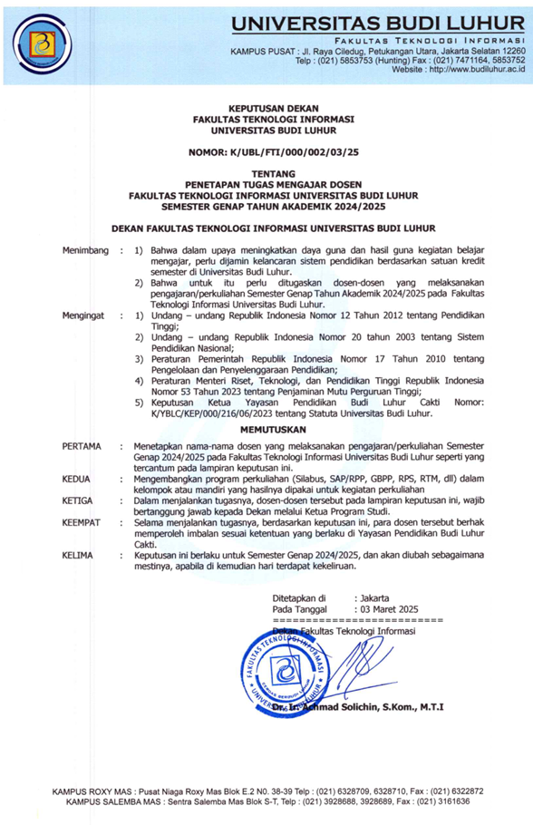
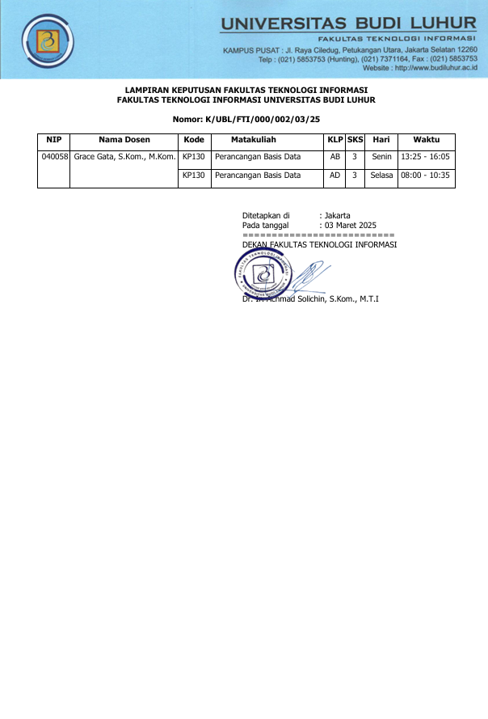

BAP
Berita Acara Mengajar
Fakultas: Fakultas Teknologi Informasi
Matakuliah: Perancangan Basis Data
Kelompok: AB
Dosen: Grace Gata, S.Kom., M.Kom.

No. | Tanggal | Sesi - Jam | Materi yang diberikan
1 | Senin 03-03-2025 | 07 - 13:25 | Proses Perancangan Basis Data
2 | Senin 10-03-2025 | 07 - 13:25 | Teknik Pengumpulan Data
3 | Senin 17-03-2025 | 07 - 13:25 | Model Konseptual dengan ER-Model
4 | Kamis 10-04-2025 | 04 - 10:40 | Model Konseptual dengan ER-Model Lanjutan
5 | Senin 14-04-2025 | 07 - 13:25 | Tahapan Perancangan ERD
6 | Senin 21-04-2025 | 07 - 13:25 | Logical Record Structure (LRS)
7 | Senin 28-04-2025 | 07 - 13:25 | Review
8 | Senin 05-05-2025 | 07 - 13:25 | UTS
9 | Kamis 15-05-2025 | 04 - 10:40 | Physical Database design
10 | Senin 19-05-2025 | 07 - 13:25 | Penormalan Relasi
11 | Senin 26-05-2025 | 07 - 13:25 | Penormalan Relasi Lanjutan
12 | Senin 02-06-2025 | 07 - 13:25 | Normalisasi lanjutan
13 | Selasa 03-06-2025 | 04 - 10:40 | Penyelesaian kasus normalisasi dan denormalisasi
14 | Senin 16-06-2025 | 07 - 13:25 | data warehouse
15 | Selasa 23-06-2025 | 04 - 10:40 | Latihan Soal
16 | Senin 07-07-2025 | 04 - 10:40 | UAS

PRESENSI
Matakuliah: Perancangan Basis Data
Kelompok: AB
Semester Genap 2024/2025
Dosen : Grace Gata, S.Kom., M.Kom.
No | NIM | Nama | 1 | 2 | 3 | 4 | 5 | 6 | 7 | 8 | 9 | 10 | 11 | 12 | 13 | 14 | 15 | 16 | %
No | NIM | Nama | 03/03 | 10/03 | 17/03 | 10/04 | 14/04 | 21/04 | 28/04 | 05/05 | 15/05 | 19/05 | 26/05 | 02/06 | 03/06 | 16/06 | 23/06 | 07/07 | %
1 | 2311500165 | Muhammad Daniel Pedrosa | Hadir | Hadir | Hadir | Hadir | Hadir | Hadir | Hadir | Hadir | Hadir | Hadir | Alpha | Hadir | Hadir | Alpha | Alpha | Alpha | 85.71
2 | 2311500181 | Muhamad Abdullah Abdur Farid | Hadir | Hadir | Hadir | Hadir | Hadir | Hadir | Hadir | Hadir | Hadir | Hadir | Hadir | Hadir | Hadir | Hadir | Hadir | Hadir | 100
3 | 2311500264 | Fajar Apriyansyah | Hadir | Hadir | Alpha | Hadir | Hadir | Hadir | Hadir | Hadir | Hadir | Hadir | Hadir | Hadir | Hadir | Hadir | Hadir | Hadir | 92.86
4 | 2311500611 | Muhammad Sigit Ramdhan | Hadir | Hadir | Hadir | Hadir | Hadir | Hadir | Hadir | Hadir | Hadir | Hadir | Hadir | Hadir | Hadir | Hadir | Hadir | Hadir | 100
5 | 2311500785 | Faaiz Fauzan | Hadir | Hadir | Hadir | Hadir | Hadir | Hadir | Hadir | Hadir | Hadir | Hadir | Hadir | Hadir | Hadir | Hadir | Hadir | Hadir | 100
6 | 2311501163 | Khaila Aldistia Naurah | Hadir | Hadir | Hadir | Hadir | Hadir | Hadir | Hadir | Hadir | Hadir | Hadir | Hadir | Hadir | Hadir | Hadir | Hadir | Hadir | 100
7 | 2311501460 | Dihya Afwan Maliki | Hadir | Hadir | Hadir | Hadir | Hadir | Hadir | Hadir | Hadir | Hadir | Hadir | Alpha | Hadir | Hadir | Alpha | Alpha | Alpha | 85.71
8 | 2311501478 | Ray Solinov | Hadir | Hadir | Hadir | Hadir | Hadir | Hadir | Hadir | Hadir | Hadir | Hadir | Hadir | Hadir | Hadir | Hadir | Hadir | Hadir | 100
9 | 2311501635 | Maulana Ibnu Hafidz Rafsyanjani | Hadir | Hadir | Hadir | Hadir | Hadir | Hadir | Hadir | Hadir | Hadir | Alpha | Hadir | Hadir | Hadir | Hadir | Hadir | Hadir | 92.86
10 | 2411500123 | Pahlevi Danu Artha | Hadir | Hadir | Hadir | Hadir | Hadir | Hadir | Hadir | Hadir | Hadir | Hadir | Hadir | Hadir | Hadir | Hadir | Hadir | Hadir | 100
11 | 2411500180 | Eriyansyah Azhari | Hadir | Hadir | Hadir | Hadir | Hadir | Hadir | Hadir | Hadir | Hadir | Hadir | Alpha | Hadir | Hadir | Hadir | Hadir | Hadir | 92.86
12 | 2411500198 | Pramudya Rangga Isdahono | Hadir | Hadir | Hadir | Hadir | Alpha | Hadir | Hadir | Hadir | Hadir | Hadir | Hadir | Hadir | Hadir | Hadir | Hadir | Hadir | 92.86
13 | 2411500297 | Farrel Lee Daffa Raia | Hadir | Hadir | Hadir | Hadir | Hadir | Hadir | Hadir | Hadir | Hadir | Hadir | Alpha | Hadir | Hadir | Hadir | Hadir | Hadir | 92.86
14 | 2411500313 | Raihan Rasya Darmawan | Hadir | Hadir | Hadir | Hadir | Hadir | Hadir | Hadir | Hadir | Hadir | Hadir | Alpha | Hadir | Hadir | Hadir | Hadir | Hadir | 92.86
15 | 2411500578 | Akbar Alfarriji | Hadir | Hadir | Hadir | Hadir | Hadir | Hadir | Hadir | Hadir | Hadir | Hadir | Alpha | Hadir | Hadir | Hadir | Hadir | Hadir | 92.86
16 | 2411500628 | Mayra Rizki | Hadir | Hadir | Hadir | Hadir | Hadir | Hadir | Hadir | Hadir | Hadir | Hadir | Hadir | Alpha | Hadir | Hadir | Hadir | Hadir | 92.86
17 | 2411500727 | Rayfan Ramadhannus | Hadir | Hadir | Hadir | Hadir | Hadir | Hadir | Hadir | Alpha | Hadir | Alpha | Alpha | Alpha | Hadir | Alpha | Alpha | Alpha | 64.29
18 | 2411500784 | Rayfa Abiyasha Hafid | Hadir | Hadir | Hadir | Hadir | Hadir | Hadir | Hadir | Hadir | Hadir | Hadir | Alpha | Hadir | Hadir | Alpha | Alpha | Alpha | 85.71
19 | 2411500800 | Muhamad Rafli Hartanto | Hadir | Hadir | Hadir | Hadir | Hadir | Hadir | Hadir | Hadir | Hadir | Hadir | Hadir | Hadir | Hadir | Hadir | Hadir | Hadir | 100
20 | 2411500982 | Idzan Hauzan Saputra | Hadir | Hadir | Hadir | Hadir | Hadir | Hadir | Hadir | Hadir | Hadir | Hadir | Hadir | Hadir | Hadir | Hadir | Hadir | Hadir | 100
21 | 2411500990 | Muhammad Thoriq Mukti Aji | Hadir | Hadir | Hadir | Hadir | Hadir | Hadir | Hadir | Hadir | Hadir | Hadir | Hadir | Hadir | Hadir | Hadir | Hadir | Hadir | 100
22 | 2411501048 | Aditya Tanaya Purwadi | Hadir | Hadir | Hadir | Hadir | Hadir | Hadir | Hadir | Hadir | Hadir | Hadir | Hadir | Hadir | Hadir | Hadir | Hadir | Hadir | 100
23 | 2411501170 | Muhammad Fauzan Wiradiwangsa | Hadir | Hadir | Hadir | Hadir | Hadir | Hadir | Hadir | Hadir | Hadir | Hadir | Alpha | Hadir | Hadir | Alpha | Alpha | Alpha | 85.71
24 | 2411501188 | Muhammad Faizul Bari | Hadir | Hadir | Hadir | Hadir | Alpha | Hadir | Hadir | Hadir | Hadir | Hadir | Hadir | Hadir | Hadir | Alpha | Alpha | Alpha | 85.71
25 | 2411501196 | Arya Dimas Pratama | Hadir | Hadir | Hadir | Hadir | Hadir | Hadir | Hadir | Hadir | Hadir | Hadir | Hadir | Hadir | Hadir | Hadir | Hadir | Hadir | 100
26 | 2411501204 | Muhammad Fadhil Subana | Hadir | Hadir | Hadir | Hadir | Hadir | Hadir | Hadir | Hadir | Hadir | Hadir | Hadir | Hadir | Hadir | Hadir | Hadir | Hadir | 100
27 | 2411501287 | Darien Yusuf | Hadir | Hadir | Hadir | Hadir | Hadir | Hadir | Hadir | Hadir | Hadir | Hadir | Alpha | Hadir | Hadir | Alpha | Alpha | Alpha | 85.71
28 | 2411501337 | Naflah Indah Afifah | Hadir | Hadir | Hadir | Hadir | Hadir | Hadir | Hadir | Hadir | Hadir | Hadir | Hadir | Hadir | Hadir | Hadir | Hadir | Hadir | 100
29 | 2411501360 | Muhammad Rosi Fattah Satria | Hadir | Hadir | Hadir | Hadir | Hadir | Hadir | Hadir | Hadir | Hadir | Hadir | Hadir | Hadir | Hadir | Hadir | Hadir | Hadir | 100
30 | 2411501485 | Rifath Mayo Fadel Landung Hescasa | Hadir | Hadir | Hadir | Hadir | Hadir | Hadir | Hadir | Hadir | Hadir | Hadir | Hadir | Hadir | Hadir | Alpha | Alpha | Alpha | 92.86
31 | 2411501634 | Muhammad Adib Fauzi | Hadir | Hadir | Hadir | Hadir | Hadir | Hadir | Hadir | Hadir | Hadir | Hadir | Hadir | Hadir | Hadir | Hadir | Hadir | Hadir | 100
32 | 2411501709 | Muhammad Ar Rayan | Hadir | Hadir | Hadir | Hadir | Hadir | Hadir | Hadir | Hadir | Hadir | Hadir | Alpha | Hadir | Hadir | Alpha | Alpha | Alpha | 85.71
33 | 2411501758 | MUHAMMAD DEAN ARYASATYA | Hadir | Hadir | Hadir | Hadir | Hadir | Hadir | Hadir | Hadir | Hadir | Hadir | Hadir | Hadir | Hadir | Hadir | Hadir | Hadir | 100
34 | 2411502087 | Adelia Zahwa Bilqis | Hadir | Hadir | Hadir | Hadir | Hadir | Hadir | Hadir | Hadir | Hadir | Hadir | Hadir | Hadir | Hadir | Hadir | Hadir | Hadir | 100
35 | 2412500122 | Muhammad Audry Fahrezi | Hadir | Hadir | Hadir | Hadir | Hadir | Hadir | Hadir | Hadir | Hadir | Hadir | Hadir | Hadir | Hadir | Hadir | Hadir | Hadir | 100
36 | 2412500148 | Muhammad Ahza Bayrizky | Alpha | Hadir | Hadir | Hadir | Hadir | Hadir | Hadir | Hadir | Hadir | Hadir | Hadir | Alpha | Hadir | Hadir | Hadir | Hadir | 85.71
37 | 2412500338 | Muhammad Naufal Abyan Shiddiq | Hadir | Hadir | Hadir | Hadir | Hadir | Hadir | Hadir | Hadir | Hadir | Alpha | Hadir | Hadir | Hadir | Hadir | Hadir | Hadir | 92.86
38 | 2412500361 | Muhammad Alfarezer Yusuf | Hadir | Hadir | Alpha | Hadir | Hadir | Hadir | Hadir | Hadir | Hadir | Hadir | Alpha | Hadir | Hadir | Alpha | Alpha | Alpha | 78.57
39 | 2412501377 | Yulia Amira | Hadir | Hadir | Hadir | Hadir | Hadir | Hadir | Hadir | Hadir | Hadir | Hadir | Hadir | Hadir | Hadir | Hadir | Hadir | Hadir | 100
40 | 2412501575 | Nasywa Agustina Suroso | Hadir | Hadir | Hadir | Hadir | Hadir | Hadir | Hadir | Hadir | Hadir | Hadir | Hadir | Hadir | Hadir | Hadir | Hadir | Hadir | 100

NILAI
Matakuliah: Perancangan Basis Data
Kelompok: AB
Dosen: Grace Gata, S.Kom., M.Kom.
Jenis: Nilai Ujian Akhir

No. | NIM | Nama | Web | BAA
1 | 2311500165 | Muhammad Daniel Pedrosa | 62 | 62
2 | 2311500181 | Muhamad Abdullah Abdur Farid | 75 | 75
3 | 2311500264 | Fajar Apriyansyah | 87 | 87
4 | 2311500611 | Muhammad Sigit Ramdhan | 85 | 85
5 | 2311500785 | Faaiz Fauzan | 72 | 72
6 | 2311501163 | Khaila Aldistia Naurah | 87 | 87
7 | 2311501460 | Dihya Afwan Maliki | 87 | 87
8 | 2311501478 | Ray Solinov | 72 | 72
9 | 2311501635 | Maulana Ibnu Hafidz Rafsyanjani | 75 | 75
10 | 2411500123 | Pahlevi Danu Artha | 60 | 60
11 | 2411500180 | Eriyansyah Azhari | 60 | 60
12 | 2411500198 | Pramudya Rangga Isdahono | 66 | 66
13 | 2411500297 | Farrel Lee Daffa Raia | 77 | 77
14 | 2411500313 | Raihan Rasya Darmawan | 60 | 60
15 | 2411500578 | Akbar Alfarriji | 60 | 60
16 | 2411500628 | Mayra Rizki | 85 | 85
17 | 2411500727 | Rayfan Ramadhannus | 999 | 999
18 | 2411500784 | Rayfa Abiyasha Hafid | 60 | 60
19 | 2411500800 | Muhamad Rafli Hartanto | 85 | 85
20 | 2411500982 | Idzan Hauzan Saputra | 60 | 60
21 | 2411500990 | Muhammad Thoriq Mukti Aji | 66 | 66
22 | 2411501048 | Aditya Tanaya Purwadi | 95 | 95
23 | 2411501170 | Muhammad Fauzan Wiradiwangsa | 60 | 60
24 | 2411501188 | Muhammad Faizul Bari | 77 | 77
25 | 2411501196 | Arya Dimas Pratama | 63 | 63
26 | 2411501204 | Muhammad Fadhil Subana | 60 | 60
27 | 2411501287 | Darien Yusuf | 65 | 65
28 | 2411501337 | Naflah Indah Afifah | 92 | 92
29 | 2411501360 | Muhammad Rosi Fattah Satria | 60 | 60
30 | 2411501485 | Rifath Mayo Fadel Landung Hescasa | 60 | 60
31 | 2411501634 | Muhammad Adib Fauzi | 60 | 60
32 | 2411501709 | Muhammad Ar Rayan | 60 | 60
33 | 2411501758 | MUHAMMAD DEAN ARYASATYA | 66 | 66
34 | 2411502087 | Adelia Zahwa Bilqis | 97 | 97
35 | 2412500122 | Muhammad Audry Fahrezi | 64 | 64
36 | 2412500148 | Muhammad Ahza Bayrizky | 64 | 64
37 | 2412500338 | Muhammad Naufal Abyan Shiddiq | 60 | 60
38 | 2412500361 | Muhammad Alfarezer Yusuf | 60 | 60
39 | 2412501377 | Yulia Amira | 97 | 97
40 | 2412501575 | Nasywa Agustina Suroso | 87 | 87

