Pelaksanaan pendidikan

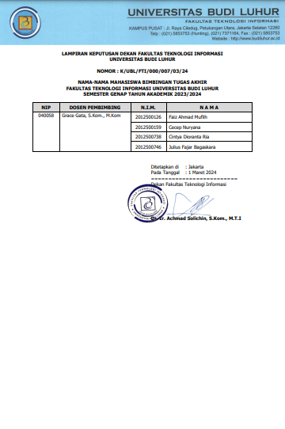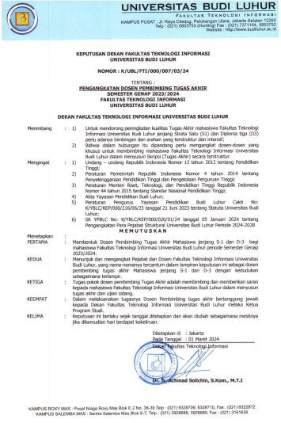D. PEMBIMBING TUGAS AKHIR

# Kartu Bimbingan Tugas Akhir

Top of Form

|  |  |  |  |
| --- | --- | --- | --- |
| No Image | NIM | : | 2012500746 |
| Nama Mahasiswa | : | Julius Fajar Bagaskara |
| Dosen Pembimbing | : | Grace Gata |
| Judul Skripsi | : | IMPLEMENTASI SISTEM PENJUALAN BERBASIS E-COMMERCE MENGGUNAKAN CONTENT MANAGEMENT SYSTEM (CMS) WOOCOMMERCE PADA PT. ALKA PASIFIK AIR |

Bottom of Form

| **No** | **Tanggal** | **Materi** |
| --- | --- | --- |
| 1 | 11-MAR-2024 | Briefing |
| 2 | 13-MAR-2024 | Bab 1 |
| 3 | 26-MAR-2024 | Dokumen berjalan |
| 4 | 09-APR-2024 | Bab 2, daftar pustaka |
| 5 | 03-MAY-2024 | metode, proses bisnis |
| 6 | 14-MAY-2024 | Bab 3 |
| 7 | 22-MAY-2024 | Bab 4 |
| 8 | 05-JUN-2024 | Lampiran |
| 9 | 18-JUN-2024 | Laporan |
| 10 | 31-JUL-2024 | Demo program |

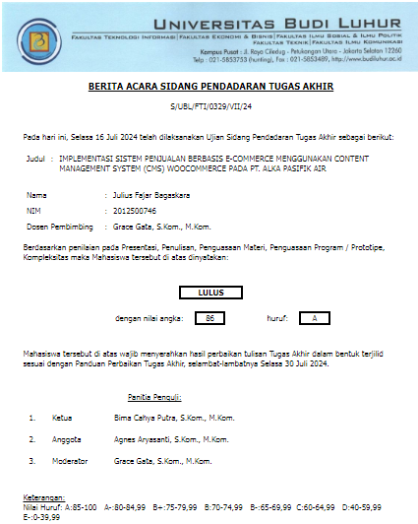

Top of Form