Penelitian
A
Jurnal Penelitian SISFOTEK

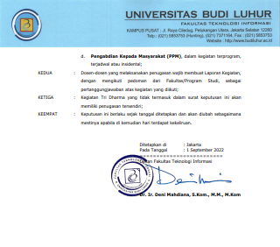
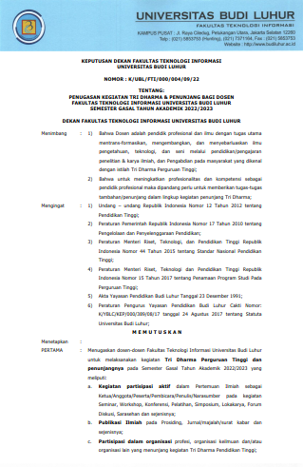
Surat Keputusan Dekan

SISFOTEK
Prosiding SISFOTEK, e-issn : 2597-3584, http://seminar.iaii.or.id/index.php/SISFOTEK, terindeks Google Scholar.dan GARUDA

http://seminar.iaii.or.id/index.php/SISFOTEK.
http://seminar.iaii.or.id/index.php/SISFOTEK/article/view/320/282