MYOB Accounting Kelompok ZZ
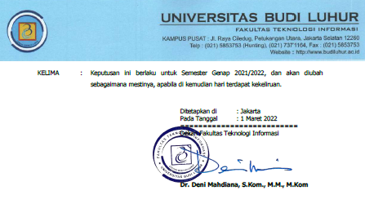
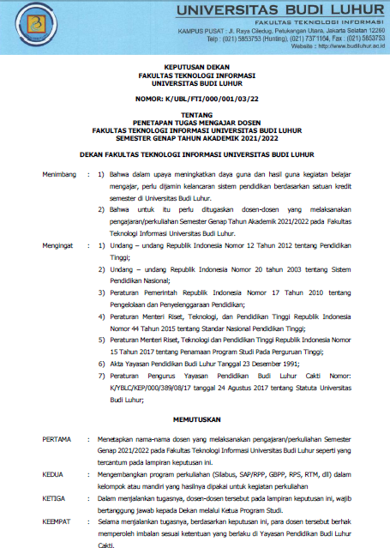
SK mengajar;

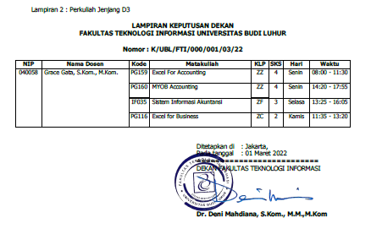
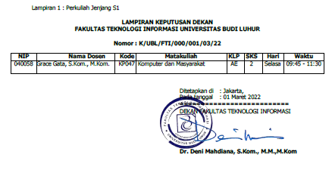

Bukti mengajar MYOB Accounting ZZ;

Berita Acara Mengajar
Fakultas: Fakultas D3 Unggulan
Matakuliah: Myob Accounting
Kelompok: ZZ
Dosen: Grace Gata, S.Kom., M.Kom.
Top of Form
No. | Tanggal | Sesi - Jam | Absensi | Materi yang diberikan
Bottom of Form
1 | Senin 07-03-2022 | 08 - 14:20 | 1. Perkembangan MYOB Accounting for Windows.  2. Pengertian MYOB Accounting for Windows.  3. Prosedur umum kerja MYOB Accounting.
2 | Senin 14-03-2022 | 08 - 14:20 | Menginstal MYOB ACCOUNTING for Windows
3 | Senin 21-03-2022 | 08 - 14:20 | MYOB Accounting for Windows
4 | Senin 28-03-2022 | 08 - 14:20 | Membukukan saldo awal
5 | Senin 04-04-2022 | 08 - 14:20 | Membukukan saldo awal (2)
6 | Senin 11-04-2022 | 08 - 14:20 | Jurnal penyesuaian
7 | Senin 18-04-2022 | 08 - 14:20 | Jurnal penyesuaian (2)
8 | Senin 25-04-2022 | 08 - 14:20 | Pembuatan laporan dengan berdasarkan kriteria, data sort, melakukan sort dan filter.
9 | Senin 09-05-2022 | 08 - 14:20 | UTS
10 | Senin 23-05-2022 | 08 - 14:20 | Menampilkan laporan keuangan
11 | Senin 30-05-2022 | 08 - 14:20 | Menyajikan laporan keuangan
12 | Senin 30-05-2022 | 12 - 18:00 | Penyelesaian kasus
13 | Senin 06-06-2022 | 08 - 14:20 | Penyesuaian dan Neraca Lajur
14 | Senin 13-06-2022 | 08 - 14:20 | Penyelesaian kasus (2)
15 | Senin 20-06-2022 | 08 - 14:20 | Penyelesaian kasus (3)
11 | Senin 30-05-2022 | 08 - 14:20 | Menyajikan laporan keuangan
12 | Senin 30-05-2022 | 12 - 18:00 | Penyelesaian kasus(4)
13 | Senin 06-06-2022 | 08 - 14:20 | Penyesuaian dan Neraca Lajur
14 | Senin 13-06-2022 | 08 - 14:20 | Penyelesaian kasus (5)
15 | Senin 20-06-2022 | 08 - 14:20 | Penyelesaian kasus (6)
16 | Senin 27-06-2022 | 08- 14:20 | UAS

Daftar Absensi

Matakuliah: MYOB Accounting
Kelompok: ZZ
Semester Genap 2021/2022
Dosen : Grace Gata, S.Kom., M.Kom.
No | NIM | Nama | 1 | 2 | 3 | 4 | 5 | 6 | 7 | 8 | 9 | 10 | 11 | 12 | 13 | 14 | 15 | 16 | %
No | NIM | Nama | 07/03 | 14/03 | 21/03 | 28/03 | 04/04 | 11/04 | 18/04 | 25/04 | 09/05 | 23/05 | 30/05 | 30/05 | 06/06 | 13/06 | 20/06 | 27/06 | %
1 | 2112300237 | Ayi Lisnawati | Hadir | Hadir | Hadir | Hadir | Hadir | Hadir | Hadir | Hadir | Hadir | Hadir | Hadir | Hadir | Hadir | Hadir | Hadir | Hadir | 100
2 | 2112300252 | Emi Andayani | Hadir | Hadir | Hadir | Hadir | Hadir | Hadir | Hadir | Hadir | Hadir | Hadir | Hadir | Hadir | Hadir | Hadir | Hadir | Hadir | 100

Daftar Nilai
Fakultas: Fakultas D3 Unggulan
Matakuliah: Myob Accounting
Kelompok: ZZ
Dosen: Grace Gata, S.Kom., M.Kom.

No. | NIM | Nama | Presensi | Tugas | Midtest | Final | Prediksi Grade
1 | 2112300237 | Ayi Lisnawati | 100 % | 100 | 95 | 95 | 97 => A
2 | 2112300252 | Emi Andayani | 100 % | 100 | 99 | 99 | 99 => A

