BIDANG B PENGAJARAN
Fakultas: Fakultas Teknologi Informasi
Matakuliah: E-Commerce
Kelompok: AA
Dosen: Grace Gata, S.Kom., M.Kom.

SK
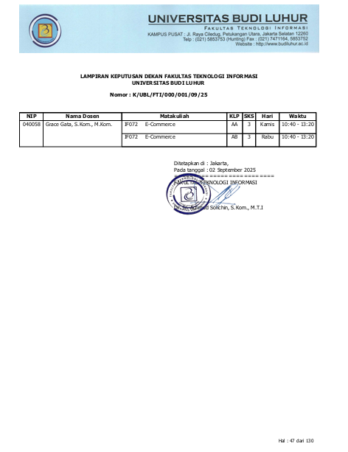
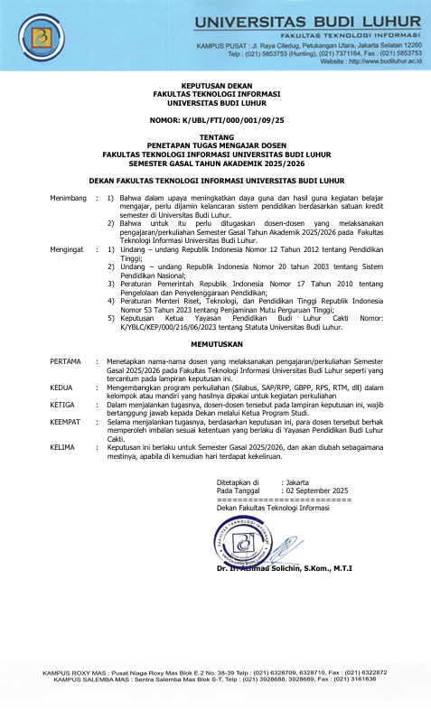

BAP
No. | Tanggal | Materi yang diberikan
1 | Kamis 18-09-2025 | Perkenalan E-commerce
2 | Kamis 25-09-2025 | Macam-macam E-Commerce
3 | Kamis 02-10-2025 | sistem transaksi E-Commerce
4 | Kamis 09-10-2025 | toko online
5 | Kamis 16-10-2025 | Keamanan E-Commerce
6 | Kamis 23-10-2025 | keamanan E-Commerce lanjutan
7 | Kamis 30-10-2025 | pasar digital
8 | Kamis 06-11-2025 | UTS
9 | Kamis 13-11-2025 | Website yang baik
10 | Rabu 19-11-2025 | Membangun e-commerce
11 | Kamis 20-11-2025 | Promosi E-Commerce
12 | Kamis 27-11-2025 | Faktor keberhasilan dan hambatan e-commerce
13 | Kamis 04-12-2025 | critical success
14 | Kamis 11-12-2025 | Implementasi E-Commerce
15 | Kamis 18-12-2025 | Implementasi E-Commerce
16 | Kamis 15-01-2026 | UAS

PRESENSI
No | NIM | Nama | 1 | 2 | 3 | 4 | 5 | 6 | 7 | 8 | 9 | 10 | 11 | 12 | 13 | 14 | 15 | 16 | %
No | NIM | Nama | 18/09 | 25/09 | 02/10 | 09/10 | 16/10 | 23/10 | 30/10 | 06/11 | 13/11 | 19/11 | 20/11 | 27/11 | 04/12 | 11/12 | 18/12 | 15/01 | %
1 | 2111500290 | Muhamad Tri Saputra | Hadir | Alpha | Alpha | Ijin | Alpha | Alpha | Ijin | Hadir | Hadir | Alpha | Alpha | Ijin | Alpha | Alpha | Alpha | Alpha | 37.5
2 | 2212500074 | Muhammad Ridwan | Hadir | Alpha | Hadir | Hadir | Hadir | Ijin | Hadir | Hadir | Hadir | Hadir | Ijin | Ijin | Hadir | Hadir | Hadir | Hadir | 93.75
3 | 2311500314 | Muhamad Faris Setiawan | Hadir | Hadir | Hadir | Hadir | Hadir | Hadir | Hadir | Hadir | Hadir | Hadir | Hadir | Hadir | Hadir | Hadir | Hadir | Hadir | 100
4 | 2311500884 | Rifqi Harits Abdurrahman | Hadir | Hadir | Hadir | Hadir | Hadir | Hadir | Hadir | Hadir | Hadir | Alpha | Hadir | Hadir | Hadir | Alpha | Hadir | Hadir | 87.5
5 | 2311500918 | Aliffansyah Aby Damar lintang | Hadir | Hadir | Hadir | Hadir | Hadir | Hadir | Hadir | Hadir | Hadir | Hadir | Hadir | Hadir | Hadir | Hadir | Hadir | Hadir | 100
6 | 2311500991 | Rakha Rasya Martdifa | Hadir | Hadir | Hadir | Hadir | Hadir | Hadir | Hadir | Hadir | Hadir | Hadir | Alpha | Ijin | Hadir | Hadir | Hadir | Hadir | 93.75
7 | 2311501544 | Samuel Atmaja | Hadir | Hadir | Hadir | Hadir | Hadir | Hadir | Ijin | Hadir | Hadir | Hadir | Hadir | Hadir | Hadir | Hadir | Hadir | Hadir | 100
8 | 2312500040 | Fina Mazaya Nasution | Hadir | Hadir | Hadir | Hadir | Hadir | Hadir | Hadir | Hadir | Hadir | Alpha | Ijin | Hadir | Hadir | Hadir | Hadir | Hadir | 93.75
9 | 2312500057 | Muhammad Arief Sudrajat | Hadir | Hadir | Hadir | Hadir | Hadir | Hadir | Hadir | Hadir | Hadir | Hadir | Hadir | Hadir | Hadir | Hadir | Hadir | Hadir | 100
10 | 2312500099 | Rifky Firmansyah | Hadir | Hadir | Hadir | Hadir | Hadir | Hadir | Hadir | Hadir | Hadir | Hadir | Hadir | Hadir | Hadir | Hadir | Hadir | Hadir | 100
11 | 2312500123 | Satia Rahmadini | Hadir | Hadir | Hadir | Hadir | Hadir | Hadir | Hadir | Hadir | Hadir | Alpha | Hadir | Ijin | Hadir | Hadir | Hadir | Hadir | 93.75
12 | 2312500156 | Fadhel Zidni Ilman Azhary | Hadir | Hadir | Hadir | Hadir | Hadir | Hadir | Hadir | Hadir | Hadir | Hadir | Hadir | Hadir | Hadir | Hadir | Hadir | Hadir | 100
13 | 2312500222 | Yessy Marie Dwi Subekti | Hadir | Hadir | Hadir | Hadir | Hadir | Hadir | Hadir | Hadir | Hadir | Hadir | Hadir | Hadir | Hadir | Hadir | Hadir | Hadir | 100
14 | 2312500230 | Dita Zia Maheswari | Hadir | Hadir | Hadir | Hadir | Hadir | Hadir | Hadir | Hadir | Hadir | Alpha | Hadir | Hadir | Hadir | Hadir | Hadir | Hadir | 93.75
15 | 2312500297 | Shanon Angelina Riqki | Hadir | Hadir | Hadir | Hadir | Hadir | Hadir | Hadir | Hadir | Hadir | Alpha | Hadir | Hadir | Hadir | Hadir | Hadir | Hadir | 93.75
16 | 2312500305 | Sheva Christian Arielle Poetra James | Alpha | Alpha | Ijin | Hadir | Hadir | Ijin | Hadir | Hadir | Hadir | Sakit | Ijin | Alpha | Hadir | Hadir | Sakit | Hadir | 81.25
17 | 2312500321 | Feranti Putri Khairunisa | Hadir | Hadir | Hadir | Hadir | Hadir | Hadir | Hadir | Hadir | Hadir | Alpha | Hadir | Hadir | Ijin | Hadir | Hadir | Hadir | 93.75
18 | 2312500339 | Muhammad Raihan | Hadir | Hadir | Hadir | Hadir | Ijin | Hadir | Hadir | Hadir | Hadir | Hadir | Hadir | Hadir | Hadir | Hadir | Hadir | Hadir | 100
19 | 2312500354 | Cantika Amalia | Hadir | Hadir | Hadir | Hadir | Hadir | Hadir | Hadir | Hadir | Hadir | Alpha | Hadir | Hadir | Hadir | Hadir | Hadir | Hadir | 93.75
20 | 2312500412 | Pranidya Kania Amanda | Hadir | Hadir | Hadir | Hadir | Hadir | Hadir | Hadir | Hadir | Hadir | Alpha | Hadir | Hadir | Hadir | Hadir | Hadir | Hadir | 93.75
21 | 2312500438 | Muhammad Adri Wildan | Hadir | Hadir | Ijin | Hadir | Hadir | Hadir | Hadir | Hadir | Hadir | Alpha | Hadir | Hadir | Hadir | Hadir | Hadir | Hadir | 93.75
22 | 2312500446 | Yafi Muendra Aziz | Hadir | Ijin | Ijin | Alpha | Alpha | Ijin | Alpha | Hadir | Hadir | Sakit | Hadir | Hadir | Hadir | Hadir | Hadir | Hadir | 81.25
23 | 2312500495 | Farhan Surya Putra Rizky | Hadir | Hadir | Hadir | Hadir | Hadir | Hadir | Hadir | Hadir | Hadir | Alpha | Ijin | Hadir | Hadir | Hadir | Alpha | Hadir | 87.5
24 | 2312500560 | Ramdhan Al Djabir | Hadir | Hadir | Hadir | Hadir | Hadir | Hadir | Hadir | Hadir | Hadir | Alpha | Hadir | Hadir | Hadir | Hadir | Hadir | Hadir | 93.75
25 | 2312500586 | Fadhli Atharrafi Adani | Hadir | Hadir | Hadir | Hadir | Hadir | Hadir | Hadir | Hadir | Hadir | Hadir | Hadir | Hadir | Hadir | Hadir | Hadir | Hadir | 100
26 | 2312500644 | Nicholas William | Ijin | Ijin | Ijin | Ijin | Ijin | Alpha | Hadir | Hadir | Hadir | Alpha | Alpha | Sakit | Sakit | Sakit | Hadir | Sakit | 81.25
27 | 2312500669 | Faiq Hibatullah | Hadir | Hadir | Hadir | Hadir | Hadir | Hadir | Hadir | Hadir | Hadir | Alpha | Hadir | Hadir | Hadir | Alpha | Hadir | Hadir | 87.5
28 | 2312500685 | Sahrul Wijaya | Hadir | Hadir | Hadir | Hadir | Hadir | Hadir | Hadir | Hadir | Hadir | Hadir | Hadir | Hadir | Hadir | Hadir | Hadir | Hadir | 100
29 | 2312500818 | Tiara Anisa Laoere | Hadir | Hadir | Hadir | Hadir | Hadir | Hadir | Hadir | Hadir | Hadir | Alpha | Hadir | Hadir | Hadir | Hadir | Hadir | Hadir | 93.75
30 | 2312500834 | Fayza Alivia Khairunnisa | Hadir | Hadir | Hadir | Hadir | Hadir | Hadir | Hadir | Hadir | Hadir | Alpha | Hadir | Hadir | Hadir | Hadir | Hadir | Hadir | 93.75
31 | 2312500859 | Jinan Auza'i Ahnaf | Hadir | Hadir | Hadir | Hadir | Ijin | Alpha | Hadir | Hadir | Hadir | Alpha | Hadir | Hadir | Hadir | Hadir | Hadir | Hadir | 87.5
32 | 2312500990 | Nuraini Auliya | Hadir | Hadir | Hadir | Hadir | Hadir | Ijin | Hadir | Hadir | Hadir | Alpha | Ijin | Hadir | Hadir | Hadir | Hadir | Hadir | 93.75
33 | 2312501006 | Shafa Rafilah Putriyani | Hadir | Hadir | Hadir | Hadir | Hadir | Hadir | Ijin | Hadir | Hadir | Alpha | Hadir | Hadir | Hadir | Hadir | Hadir | Hadir | 93.75
34 | 2312501014 | Musa Al Kazhim | Hadir | Hadir | Ijin | Alpha | Ijin | Ijin | Hadir | Hadir | Hadir | Alpha | Ijin | Ijin | Hadir | Alpha | Ijin | Hadir | 81.25
35 | 2312501022 | I Wayan Wirartha Putra | Hadir | Hadir | Hadir | Hadir | Hadir | Hadir | Hadir | Hadir | Hadir | Hadir | Alpha | Hadir | Hadir | Hadir | Hadir | Hadir | 93.75
36 | 2312501048 | Wahyu Ramadhani | Hadir | Hadir | Hadir | Hadir | Hadir | Hadir | Hadir | Hadir | Hadir | Alpha | Hadir | Hadir | Hadir | Hadir | Hadir | Hadir | 93.75
37 | 2312501055 | Laula Deswenta | Hadir | Hadir | Hadir | Hadir | Hadir | Hadir | Hadir | Hadir | Hadir | Alpha | Hadir | Hadir | Hadir | Hadir | Hadir | Hadir | 93.75
38 | 2312501063 | Fidya Zahrani Nanduary | Hadir | Hadir | Hadir | Hadir | Hadir | Hadir | Hadir | Hadir | Hadir | Alpha | Hadir | Hadir | Hadir | Hadir | Hadir | Hadir | 93.75
39 | 2312501071 | Vioni Rahma Maynanda | Hadir | Hadir | Hadir | Hadir | Hadir | Ijin | Hadir | Hadir | Hadir | Alpha | Hadir | Hadir | Hadir | Hadir | Hadir | Hadir | 93.75
40 | 2312501105 | Zaydan Afzaal Falih | Hadir | Hadir | Hadir | Hadir | Ijin | Hadir | Hadir | Hadir | Hadir | Alpha | Hadir | Hadir | Hadir | Hadir | Hadir | Hadir | 93.75
41 | 2312501154 | Fadhlan Ramadhan | Hadir | Hadir | Ijin | Hadir | Hadir | Hadir | Hadir | Hadir | Hadir | Alpha | Hadir | Hadir | Hadir | Hadir | Hadir | Hadir | 93.75
42 | 2312501162 | Zahra Afifah | Hadir | Hadir | Hadir | Hadir | Hadir | Hadir | Alpha | Hadir | Hadir | Hadir | Hadir | Hadir | Hadir | Hadir | Hadir | Hadir | 93.75

NILAI

No. | NIM | Nama | Web | BAA
1 | 2111500290 | Muhamad Tri Saputra | 999 | 999
2 | 2212500074 | Muhammad Ridwan | 88 | 88
3 | 2311500314 | Muhamad Faris Setiawan | 92 | 92
4 | 2311500884 | Rifqi Harits Abdurrahman | 94 | 94
5 | 2311500918 | Aliffansyah Aby Damar lintang | 94 | 94
6 | 2311500991 | Rakha Rasya Martdifa | 94 | 94
7 | 2311501544 | Samuel Atmaja | 94 | 94
8 | 2312500040 | Fina Mazaya Nasution | 86 | 86
9 | 2312500057 | Muhammad Arief Sudrajat | 94 | 94
10 | 2312500099 | Rifky Firmansyah | 96 | 96
11 | 2312500123 | Satia Rahmadini | 90 | 90
12 | 2312500156 | Fadhel Zidni Ilman Azhary | 92 | 92
13 | 2312500222 | Yessy Marie Dwi Subekti | 84 | 84
14 | 2312500230 | Dita Zia Maheswari | 84 | 84
15 | 2312500297 | Shanon Angelina Riqki | 94 | 94
16 | 2312500305 | Sheva Christian Arielle Poetra James | 76 | 76
17 | 2312500321 | Feranti Putri Khairunisa | 90 | 90
18 | 2312500339 | Muhammad Raihan | 90 | 90
19 | 2312500354 | Cantika Amalia | 98 | 98
20 | 2312500412 | Pranidya Kania Amanda | 94 | 94
21 | 2312500438 | Muhammad Adri Wildan | 92 | 92
22 | 2312500446 | Yafi Muendra Aziz | 96 | 96
23 | 2312500495 | Farhan Surya Putra Rizky | 90 | 90
24 | 2312500560 | Ramdhan Al Djabir | 96 | 96
25 | 2312500586 | Fadhli Atharrafi Adani | 96 | 96
26 | 2312500644 | Nicholas William | 72 | 72
27 | 2312500669 | Faiq Hibatullah | 94 | 94
28 | 2312500685 | Sahrul Wijaya | 96 | 96
29 | 2312500818 | Tiara Anisa Laoere | 94 | 94
30 | 2312500834 | Fayza Alivia Khairunnisa | 94 | 94
31 | 2312500859 | Jinan Auza'i Ahnaf | 92 | 92
32 | 2312500990 | Nuraini Auliya | 92 | 92
33 | 2312501006 | Shafa Rafilah Putriyani | 96 | 96
34 | 2312501014 | Musa Al Kazhim | 82 | 82
35 | 2312501022 | I Wayan Wirartha Putra | 90 | 90
36 | 2312501048 | Wahyu Ramadhani | 86 | 86
37 | 2312501055 | Laula Deswenta | 96 | 96
38 | 2312501063 | Fidya Zahrani Nanduary | 84 | 84
39 | 2312501071 | Vioni Rahma Maynanda | 90 | 90
40 | 2312501105 | Zaydan Afzaal Falih | 96 | 96
41 | 2312501154 | Fadhlan Ramadhan | 74 | 74
42 | 2312501162 | Zahra Afifah | 96 | 96

