BIDANG B PENGAJARAN
Fakultas: Fakultas Teknologi Informasi
Matakuliah: Audit Sistem Informasi
Kelompok: S3
Dosen: Grace Gata, S.Kom., M.Kom.

SK

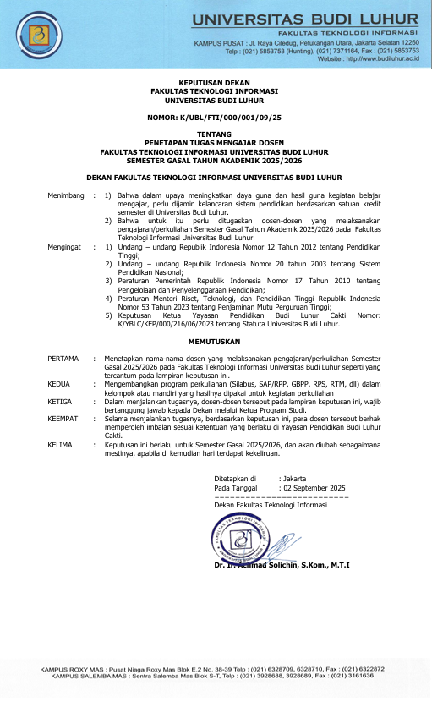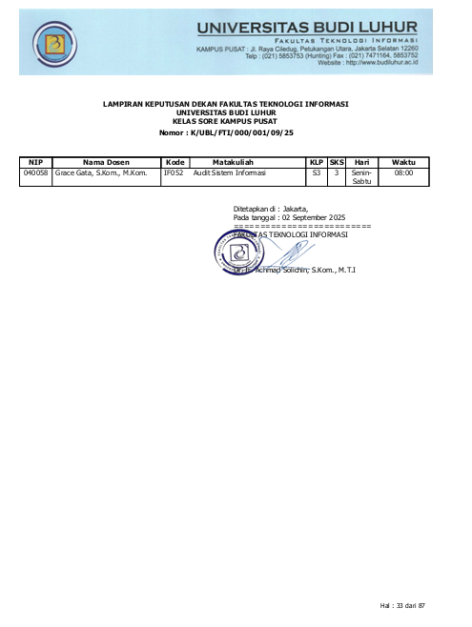

BAP
Berita Acara Mengajar

No. | Tanggal | Materi yang diberikan
1 | 01-11-2025 | Pengantar Audit Sistem Informasi
2 | 03-11-2025 | Proses Audit
3 | 08-11-2025 | Laporan Hasil Audit Sistem Informasi
4 | 10-11-2025 | Audit Tata Kelola Teknologi Informasi
5 | 15-11-2025 | Auditing Bussiness Continuity
6 | 17-11-2025 | Teknik Audit Berbantu Komputer
7 | 22-11-2025 | Audit Application Control
8 | 24-11-2025 | UTS
9 | 29-11-2025 | Audit Sistem Development dan pemeliharaan sistem
10 | 01-12-2025 | Audit Infrastruktur dan Operasional
11 | 06-12-2025 | Audit Kerangka Manajemen Keamanan Informasi
12 | 08-12-2025 | Audit Keamanan Infrastruktur Jaringan
13 | 13-12-2025 | Menginstal ActiveData For Excel
14 | 15-12-2025 | Audit Buku Besar Umum (General Ledger)
15 | 20-12-2025 | Pengendalian Perspektif Manajemen
16 | 22-12-2025 | UAS

PRESENSI

No | NIM | Nama | 1 | 2 | 3 | 4 | 5 | 6 | 7 | 8 | 9 | 10 | 11 | 12 | 13 | 14 | 15 | 16 | %
No | NIM | Nama | 01/11 | 03/11 | 08/11 | 10/11 | 15/11 | 17/11 | 22/11 | 24/11 | 29/11 | 01/12 | 06/12 | 08/12 | 13/12 | 15/12 | 20/12 | 22/12 | %
1 | 2111510513 | Muhammad Tristan Cahyadi | Alpha | Alpha | Alpha | Ijin | Ijin | Ijin | Ijin | Hadir | Hadir | Ijin | Hadir | Ijin | Ijin | Ijin | Hadir | Hadir | 81.25
2 | 2211510199 | Ilham Abdul Aziss | Hadir | Hadir | Hadir | Alpha | Hadir | Ijin | Hadir | Hadir | Hadir | Alpha | Hadir | Hadir | Hadir | Alpha | Hadir | Hadir | 81.25
3 | 2211510256 | Hafizh Maulana Yusliansyah | Hadir | Hadir | Ijin | Hadir | Hadir | Hadir | Hadir | Hadir | Hadir | Hadir | Hadir | Hadir | Ijin | Hadir | Hadir | Hadir | 100
4 | 2211510280 | Firdhan Happyanda | Hadir | Hadir | Hadir | Hadir | Hadir | Hadir | Hadir | Hadir | Hadir | Hadir | Hadir | Hadir | Ijin | Hadir | Hadir | Hadir | 100
5 | 2211510488 | Amalia Zakia Zhk | Hadir | Hadir | Hadir | Hadir | Alpha | Alpha | Alpha | Hadir | Hadir | Hadir | Hadir | Hadir | Hadir | Hadir | Hadir | Hadir | 81.25
6 | 2211510504 | Adistira Garin Nugraha | Alpha | Alpha | Alpha | Ijin | Hadir | Hadir | Hadir | Hadir | Hadir | Hadir | Hadir | Hadir | Ijin | Ijin | Hadir | Hadir | 81.25
7 | 2211510637 | Lingga Andika Setiabudi | Hadir | Hadir | Hadir | Hadir | Alpha | Hadir | Hadir | Hadir | Hadir | Alpha | Ijin | Alpha | Ijin | Hadir | Hadir | Hadir | 81.25
8 | 2211510645 | Eki Oktaviana Ripaldi | Hadir | Hadir | Hadir | Alpha | Ijin | Alpha | Ijin | Hadir | Hadir | Ijin | Ijin | Alpha | Hadir | Hadir | Hadir | Hadir | 81.25
9 | 2211510652 | Abdulloh Mahmud Jalaludin | Alpha | Hadir | Ijin | Alpha | Alpha | Alpha | Alpha | Hadir | Hadir | Alpha | Alpha | Alpha | Alpha | Alpha | Hadir | Alpha | 31.25
10 | 2211510660 | Febby Syahrul Fahrurodzi | Hadir | Hadir | Hadir | Hadir | Alpha | Alpha | Hadir | Hadir | Hadir | Hadir | Hadir | Alpha | Ijin | Ijin | Hadir | Hadir | 81.25
11 | 2211510900 | Muhammad Saddam Khadafi | Hadir | Hadir | Hadir | Hadir | Hadir | Hadir | Alpha | Hadir | Hadir | Hadir | Hadir | Hadir | Alpha | Hadir | Hadir | Hadir | 87.5
12 | 2212510032 | Siti Fatimah | Alpha | Hadir | Alpha | Ijin | Ijin | Hadir | Alpha | Hadir | Hadir | Hadir | Ijin | Ijin | Ijin | Hadir | Hadir | Hadir | 81.25
13 | 2212510065 | Mugi Sekar Rahayu | Alpha | Hadir | Alpha | Ijin | Alpha | Ijin | Ijin | Hadir | Hadir | Ijin | Ijin | Ijin | Ijin | Ijin | Hadir | Hadir | 81.25
14 | 2311510511 | Anzela Fi Adha El Faza | Hadir | Hadir | Hadir | Alpha | Hadir | Alpha | Hadir | Hadir | Hadir | Ijin | Ijin | Hadir | Hadir | Alpha | Hadir | Hadir | 81.25
15 | 2312510320 | Davina Astrid Luthfiandra | Hadir | Hadir | Hadir | Hadir | Hadir | Hadir | Alpha | Hadir | Hadir | Alpha | Hadir | Alpha | Hadir | Hadir | Hadir | Hadir | 81.25
16 | 2312510395 | Kurnia Darmawan | Hadir | Hadir | Hadir | Hadir | Ijin | Hadir | Alpha | Hadir | Hadir | Alpha | Hadir | Alpha | Hadir | Hadir | Hadir | Hadir | 81.25
17 | 2312510577 | Wahyu Febrianto | Hadir | Hadir | Hadir | Alpha | Hadir | Alpha | Hadir | Hadir | Hadir | Ijin | Ijin | Ijin | Hadir | Alpha | Hadir | Hadir | 81.25
18 | 2412510360 | Mirqatul Fadhillah | Hadir | Hadir | Ijin | Hadir | Alpha | Alpha | Alpha | Hadir | Hadir | Hadir | Hadir | Hadir | Ijin | Ijin | Hadir | Hadir | 81.25
19 | 2412510550 | Mukhlish | Hadir | Hadir | Hadir | Hadir | Hadir | Hadir | Hadir | Hadir | Hadir | Hadir | Hadir | Hadir | Hadir | Hadir | Hadir | Hadir | 100
20 | 2512510435 | Yohanes Imanuel Kanipa | Alpha | Hadir | Ijin | Hadir | Ijin | Ijin | Alpha | Hadir | Hadir | Alpha | Ijin | Ijin | Alpha | Ijin | Hadir | Alpha | 68.75

NILAI
No. | NIM | Nama | Web | BAA
1 | 2111510513 | Muhammad Tristan Cahyadi | 97 | 97
2 | 2211510199 | Ilham Abdul Aziss | 87 | 87
3 | 2211510256 | Hafizh Maulana Yusliansyah | 97 | 97
4 | 2211510280 | Firdhan Happyanda | 96 | 96
5 | 2211510488 | Amalia Zakia Zhk | 91 | 91
6 | 2211510504 | Adistira Garin Nugraha | 93 | 93
7 | 2211510637 | Lingga Andika Setiabudi | 86 | 86
8 | 2211510645 | Eki Oktaviana Ripaldi | 92 | 92
9 | 2211510652 | Abdulloh Mahmud Jalaludin | 999 | 999
10 | 2211510660 | Febby Syahrul Fahrurodzi | 89 | 89
11 | 2211510900 | Muhammad Saddam Khadafi | 89 | 89
12 | 2212510032 | Siti Fatimah | 91 | 91
13 | 2212510065 | Mugi Sekar Rahayu | 95 | 95
14 | 2311510511 | Anzela Fi Adha El Faza | 94 | 94
15 | 2312510320 | Davina Astrid Luthfiandra | 91 | 91
16 | 2312510395 | Kurnia Darmawan | 92 | 92
17 | 2312510577 | Wahyu Febrianto | 79 | 79
18 | 2412510360 | Mirqatul Fadhillah | 78 | 78
19 | 2412510550 | Mukhlish | 93 | 93
20 | 2512510435 | Yohanes Imanuel Kanipa | 999 | 999

